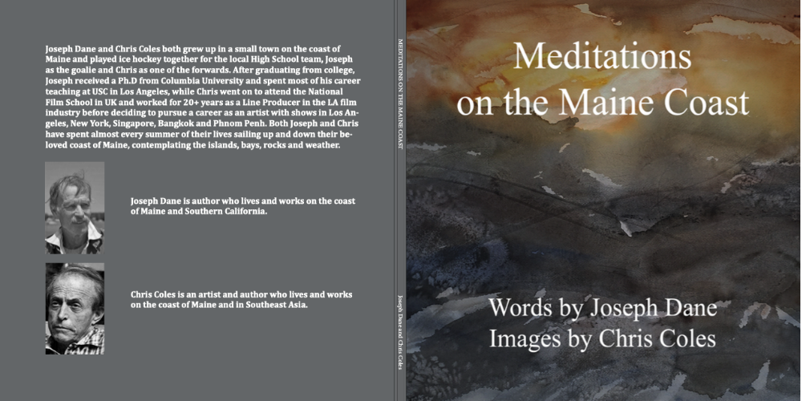

MEDITATIONS ON THE MAINE COAST

Words by Joseph Dane Images from Chris Coles

Copyright © 2023 by Joseph Dane and Chris Coles
All rights reserved
Los Angeles: FreeReadPress, 2023
ISBN: 9798872364153

Meditations

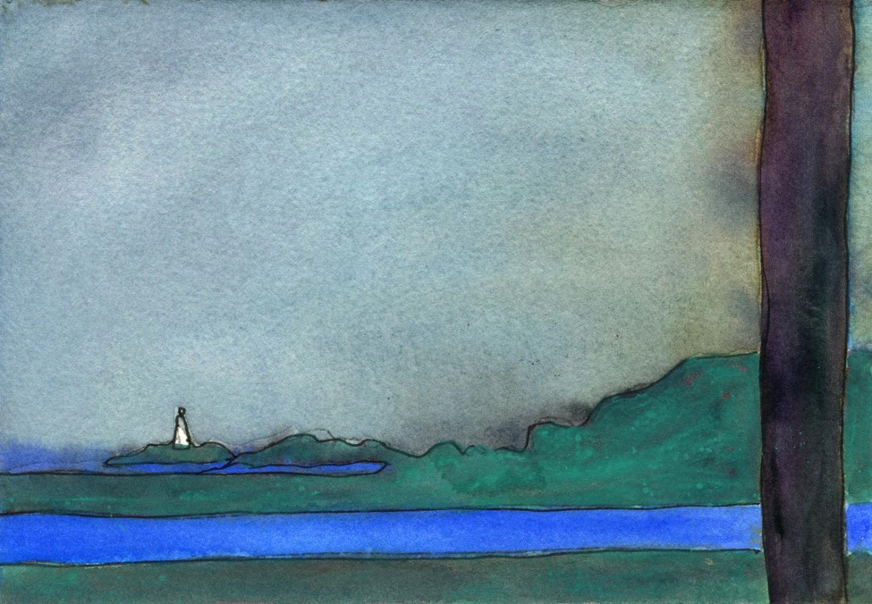

In ancient times—when we were kids I mean—one half-century and half a half of that ago, the soap dish was always full, the canvasses all primed, the arrows fletchered up. Sled-run turns were banked, the ice scraped clean for the skate-blades, the fires always lit in the old colonials.

There was no confusion then, no blurring of the land and the sea surface. No trees blocked the vistas out to the island monument; no enemy defenders dug defiantly in on the beachfront. Strips of sea were always blue.

There was a certain rectitude to how things were, a rightness, assured to us by pipe-puffing founders of schools of criticism, art, and poetry, found wherever you might study then. What was near was near; the far far off in the distance.

The sky was filled with flecks of lead.

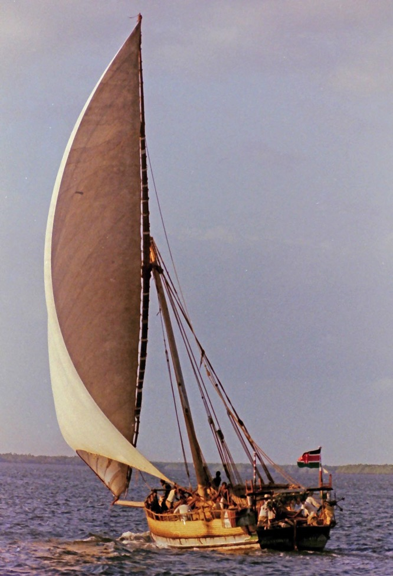

We lived then as we were shown, following the tracks and ruts of our elders, sailing in home-built or imagined skiffs, building towers in the snow like the Inuit, or Eskimos as they were known, exotic to us as the Indians, when we still called them that.

Oil so cheap the wood we stacked was all for show, the lives and works of our forebears all for show, like bourgeois grandeurs of life for show.

Like the wind-filled sails of the dhows you sailed in the trades at Lamu all for show always and only shown only imagined with the spar to lee.

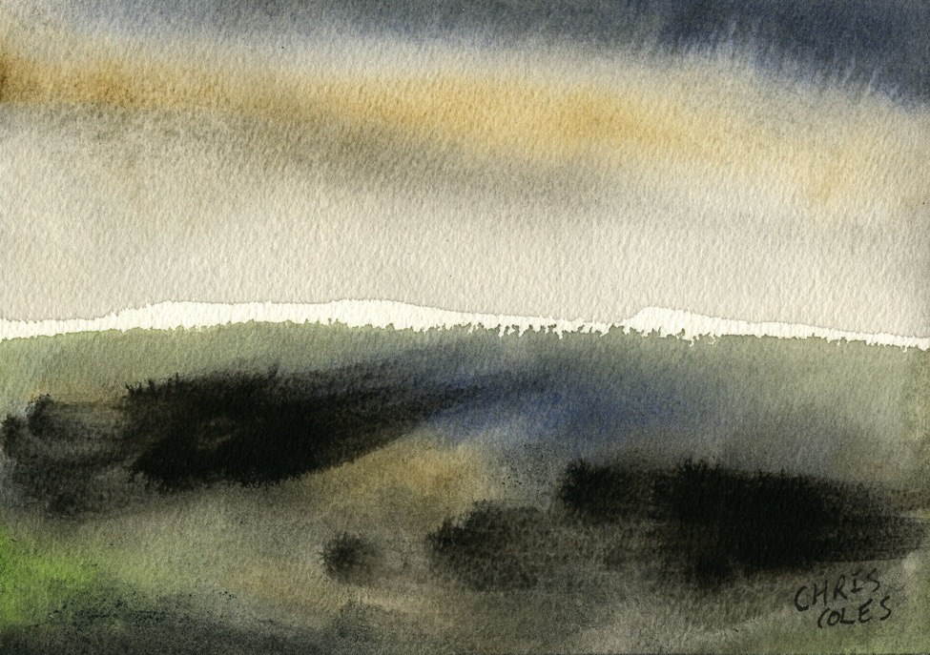

We dreamed as kids in dreamlike monochrome, dreaming of Greenland scouting locations for the film crew, of scenes as seen by my uncle, sailing with Byrd to Antarctica, or felt on Shackleton’s two winters on the ice, the way we imagined them, nursing hot chocolate, tuning the rabbit ears on the old Motorola.

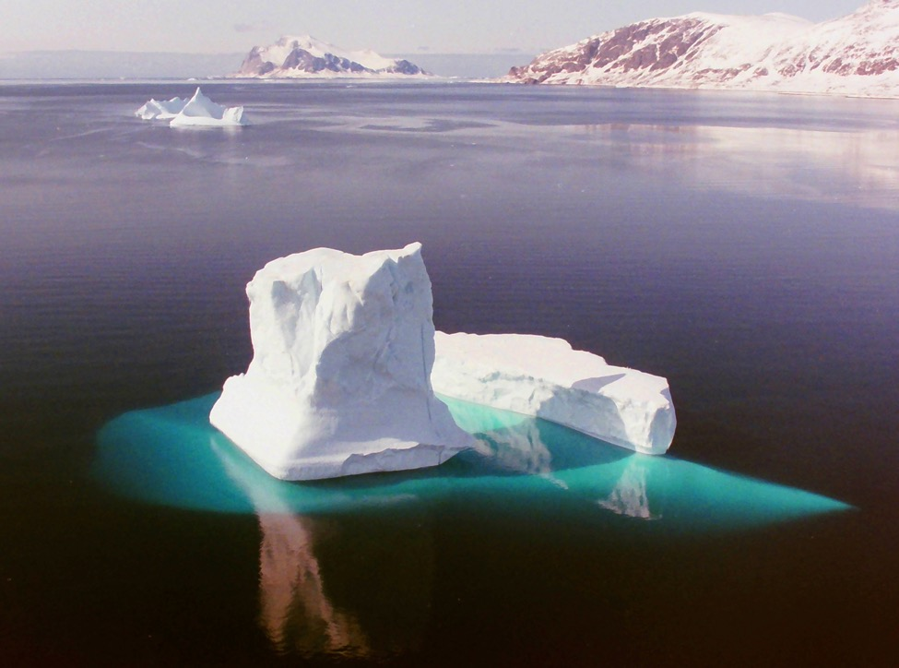

Only the ice floes refracted the light of the ice-scape.

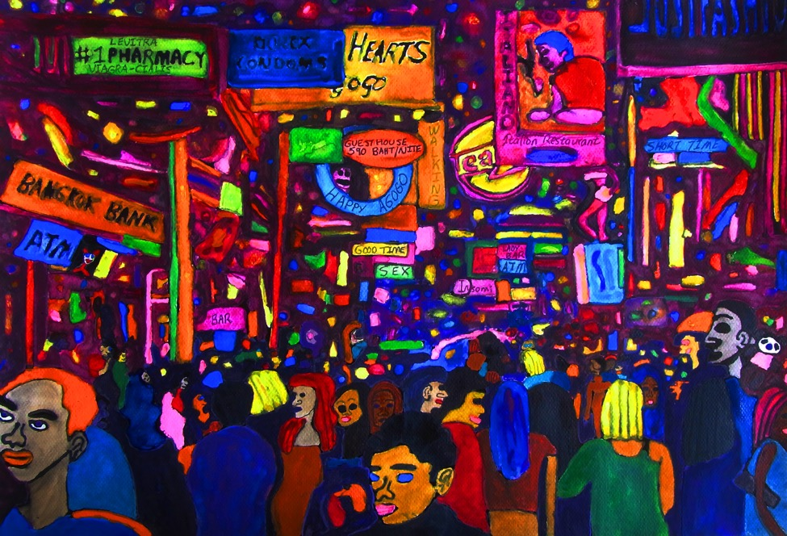

The gaffer turns from his workbench, the glare of the posters as if back-lit in the black-light. The glass bulbs flash at unpredicted intervals, like life, he says, too gnomically to know what he might mean by this.

“That’s the point of it,” he says, soldering in the capacitors, what you were taught but never learned in shop class, the wires in the schematic a confusion of color-coded spaghetti-strands to you, a cliché of course, and in godly Down East innocence, you ate it straight from the can.

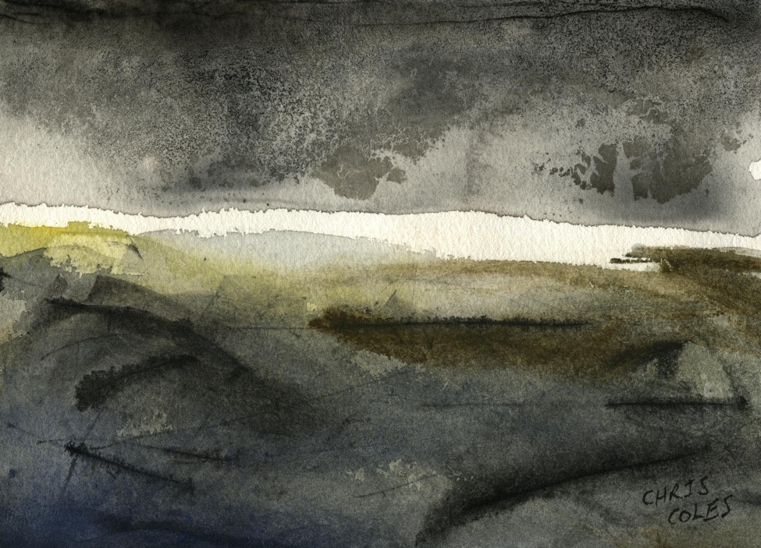

The romancier sees stories, so he said, painters patterns, even in the random flashings of this light panel, the uncoiled cordage or cords of the cord-wood, the stars too, I guess, before the Greeks named the constellations.

Like the disjointed clutter of all you’ve experienced in life—Bangkok bars or strip clubs in Hollywood, marriage vows, trophies in the trophy room, the hard-edged sagacities we learned in grammar school—all that becomes a self today you claim.

You have to look. You have to see again. That’s what he insisted on.

The dancers bent into position.
The sailors posed for the photographs.

The landscapes framed for the photographs.
The paint unglazed on the easel.

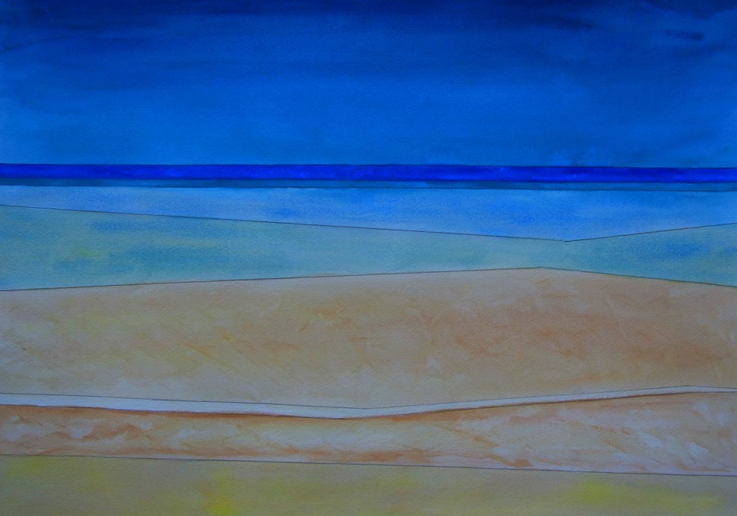

“Painted to death, twenty-five thousand times by now,” you scoffed, your very words. ‘‘Seascapes from Maine to California, the straits of Malacca. ‘Variations on a theme by Rothko’, I call them. Why would I add to their number? As in the Academies of a century and a half ago, all they taught was getting the waves right or convincing their clients they got the waves right, shaping all for walls of summer cottages, posters for the corridors of motels one finds acceptable.

“The ‘fraud of description’, you writers called it once, as if all beaches stretched to a brilliant sea, as if art were merely Wyeth’s sanitized reality. No wonder Blake dropped out of art school.

“Now Hartley,” you said, “Hartley always got the colors right, the vistas Steve Etnier,
that old philanderer, but let’s not get into that right now!”

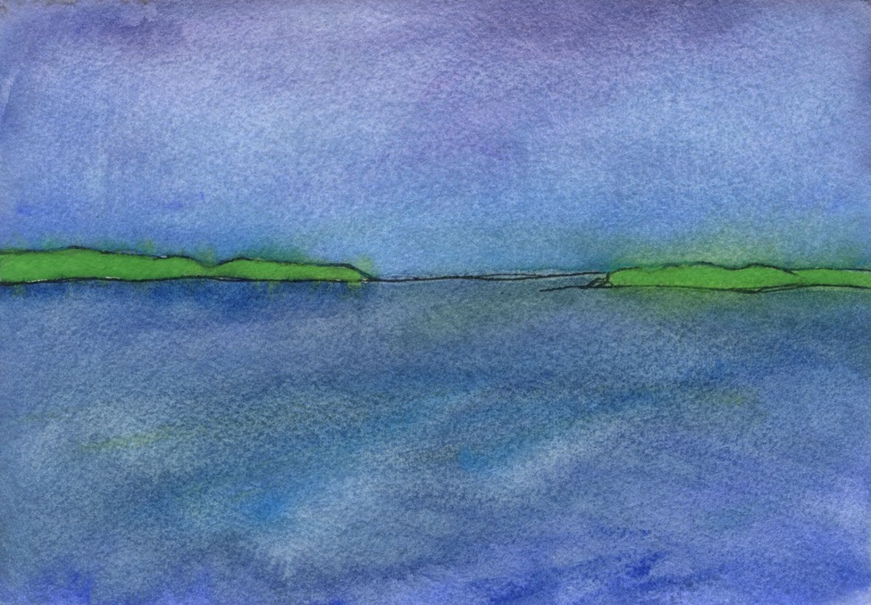

“Oh you know the vista,” you added, as we drifted in the inconstant air waiting for the south wind, “always the same to them, always the same,” you said. “Some wanderer from away pulls out their cell-phone sitting back on their kayak or athwart their paddle-board, new-bought from Bean’s, and centers the prow in the foreground, their spear now at rest, I guess, like those awful selfies of the beach with the legs outstretched out toward the horizon. Deaf to the plaints of the miners beneath them.”

“Playing Maine, I called it, not living it.”

“Remember the day at the anchorage? we pushed through the shallows where the fish lay in waiting, nothing on the surface to tell of them, only the fraud of the instruments, and the money-changers on the wharf at Interstate.”

“Or the morning we lowered ourselves into the reeds in the shade of Katahdin just as the drugs took hold of us,” I answered, “lifted us in the water, ‘This is such a bad idea,’ I thought quoting you, Alexis, you staring up to me on the jetty in the rain.”

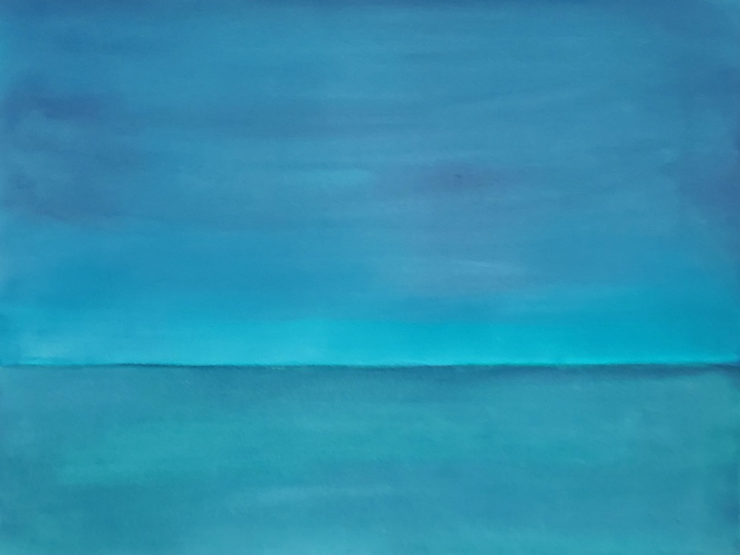

“And then I looked again, an artist now, into the undepicted sea itself I looked, and all became the sea that day, the way all became the sea for you that first day sailing out of Roque Island in the Northwest gale, no more days lost in the anchorage, you vowed, rounding Petit Manaan as the gusts shot across the bow like cannon blasts you say, never having seen or experienced one, remember that? all the yachts from the yacht clubs of New York huddled on rented moorings, intent on the weather reports on the screens of their chart-plotters … oh how you tell it! … with your jury-rigged storm rig you set your anchors, turning back to see the idling yachtsmen shaking their heads in resentment; you sailed off as soon as the dawn broke while the sailors from away were still in their nightshirts.”

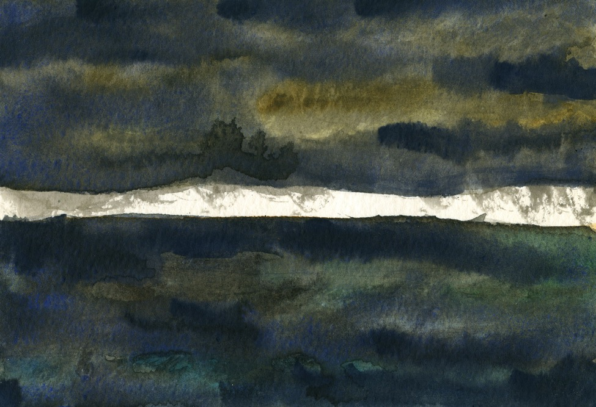

“By noon, the first squall came out of the cloud bank and you reefed down to the foresail, hull-speed on a broad reach, barely home before the hail blew suddenly in horizontal bands across the deck as the woman you loved, with hardly a nod of acknowledgement, as the woman you had once loved strode proudly with her family with her fawning friends with her latest lover strode off the wharf back to her summer home.”

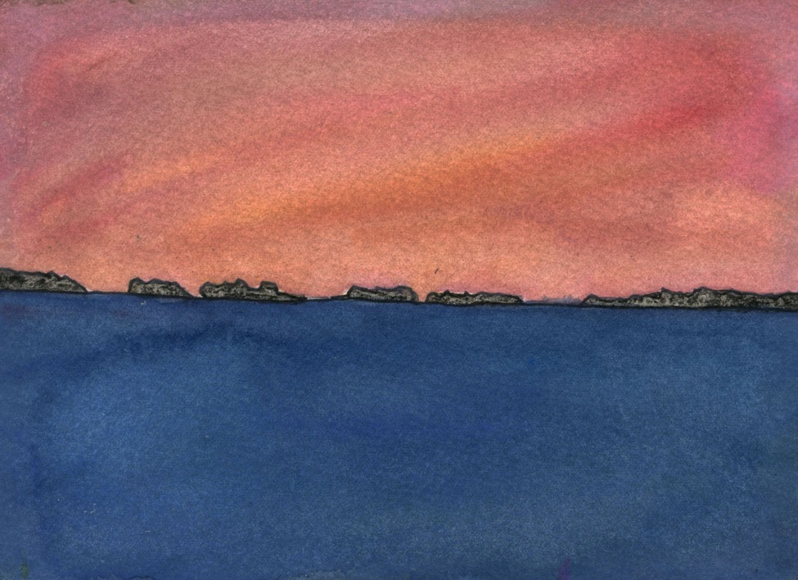

Dawn after dawn, as seen from the foredeck, so it seemed and so it seemed to her,
each dawn like the others, each wail of the loons like others like too the cries of the fishermen like the cries of the couple drowned off Saddleback the same cries they seemed to you as she dozed off against the mast-step.

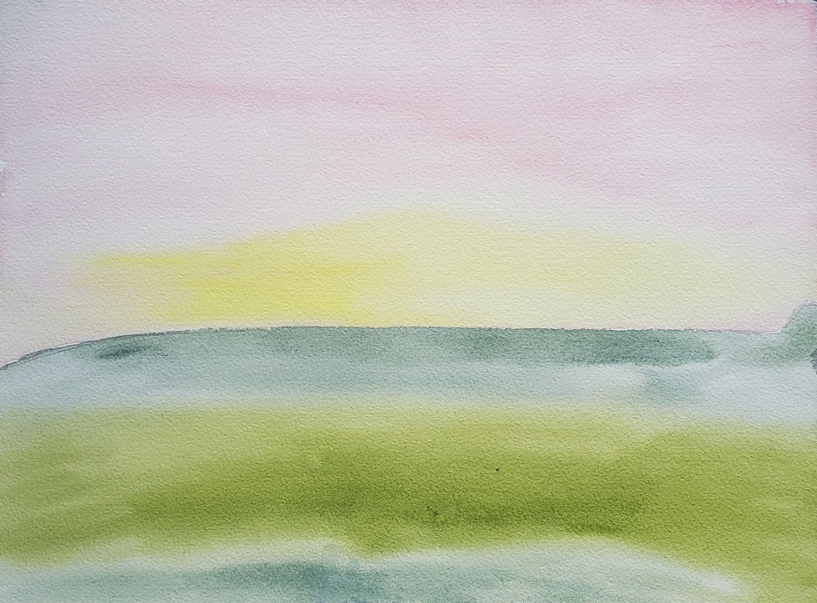

The sun broke through the fog and burned a glow over and in the water; Turneresque, it was, the light far more than anything it shows, the sea-surfaces “like mirrors” as the bad poets say, never having seen them, never having felt the buoyancies or the first warmth of the morning before the sea-breezes rise from the persistent ocean high.

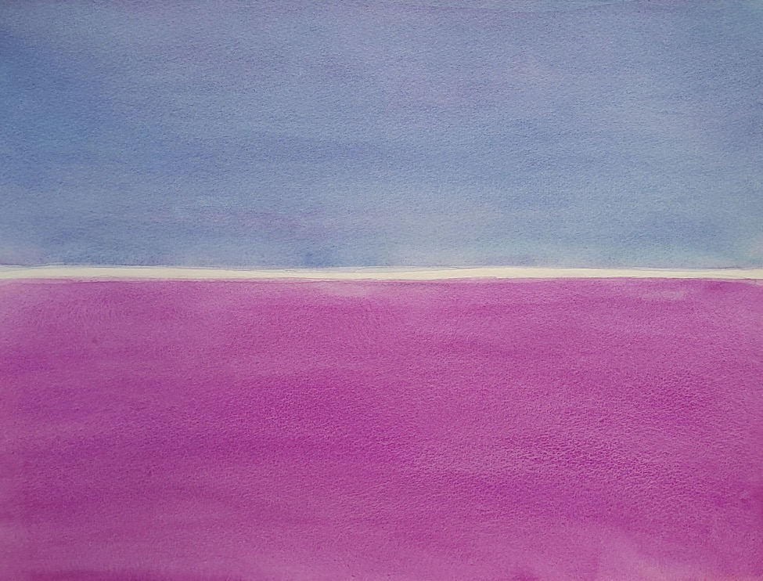

She didn’t come to until we were out in the sun-flecked bay with the fishermen, diesel tones like all the other diesels in the bay and for once she had nothing to say as if, in the soporific rhythms of the sea, the soporific rhythms of your voice, the exhaust and the smell of the baitfish—as if all those days in the academy were nothing, all those sectioned slides under the microscope, the hours reading Donne nothing too, as the professor bent over her, working through the moods and tenses, the errors of the copyists.

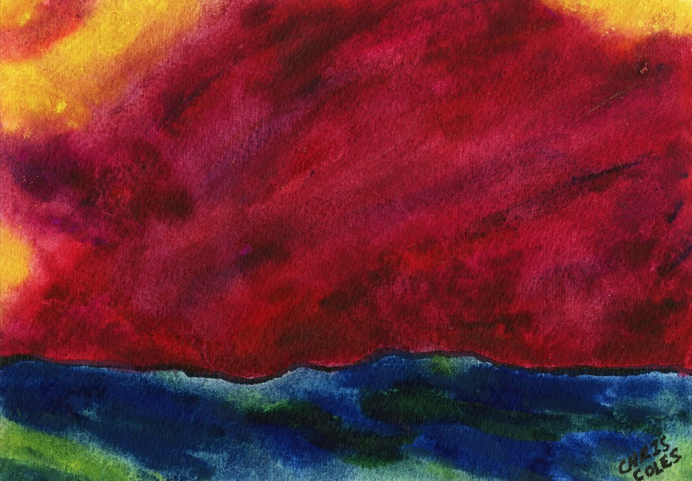

“All those fussy scansions and prosodies, the dilatoriness of feeling and of form,
missing the point the point being missing the point I guess.

“No more!” she cried in the words of the bos’n, grabbing the cat and snapping the cord-braids—Old School Dominatrix!—your back soon red with the lashing.

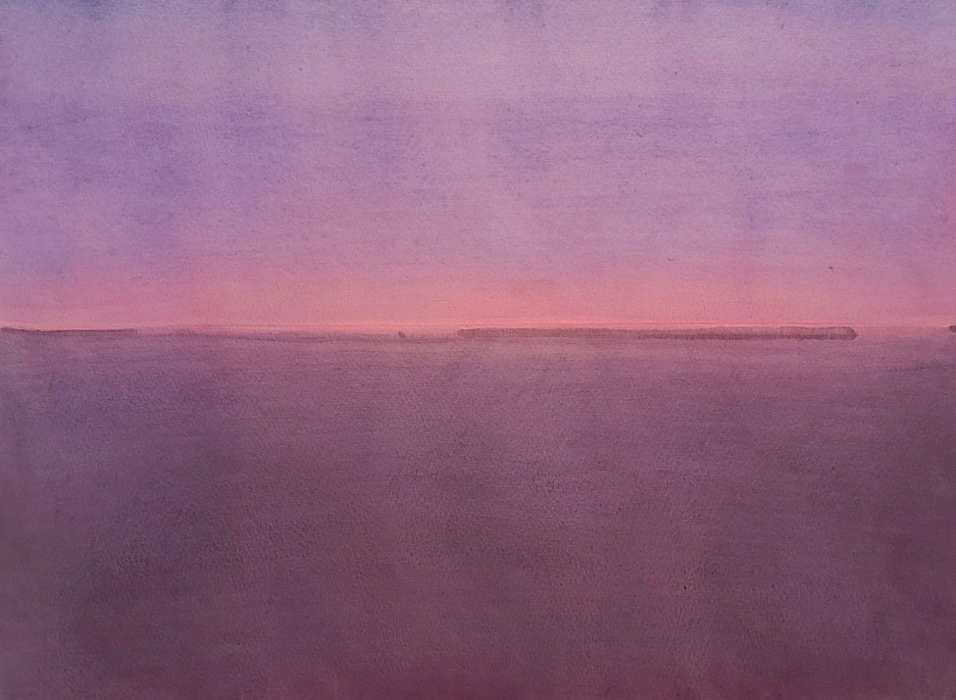

You cannot wait for the words to come to you, she said, for the light to break over the water and over the protecting ledge of the anchorage. You cannot wait for the triads and scales to grip your fingertips the way they did for your forebears. For the paint to form on the canvas.

The boat flies in the wind, you see; the air is its element, not the sea.

Do not get lost in the soundings, the waves pushed by undulations of the sea-floor.

That’s what the old fisherman taught to me as we hauled back the catch in the rain.

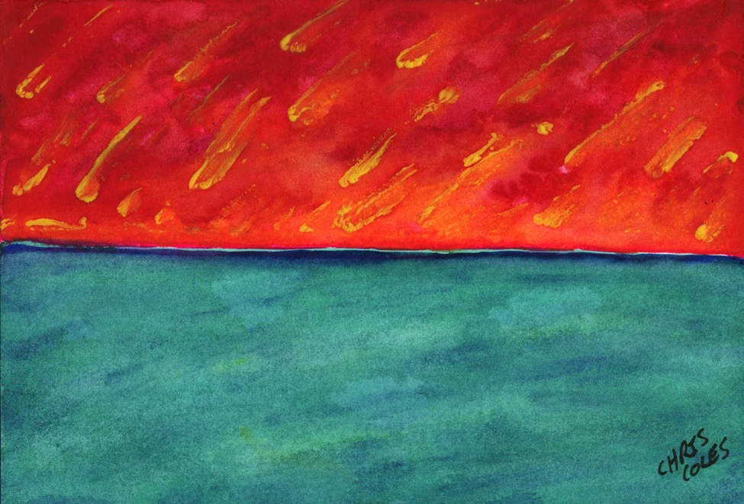

So they drifted in, the poets did, the painters from the art schools, the oboists and flautists from conservatories, all proficient all professional, committed to the grandeur of the enterprise. Their thinking current in the passageways, the life-forms sketched to perfection, the chapbooks heavy with quatrains.

Like the Liberty ships churned out by the thousands at wartime, all to code, all perfectly in trim, all perfectly expendable, faint islands discoloring the horizons in the lens of the periscope. What was another one? What was a squadron less? What were the missing crews, packed into lifeboats?

They said they won the war with them, that the welders and pipe-fitters at the Iron Works worked their calloused flesh impossibly to the bone they say. They say the troops were delivered to their glorious deaths with them the only variants the names on the transoms and the waves at the beachfronts, no two alike they say. And maybe that’s why they all so rarely spoke of it; maybe that’s why the sea and the sky itself went dark at Normandy.

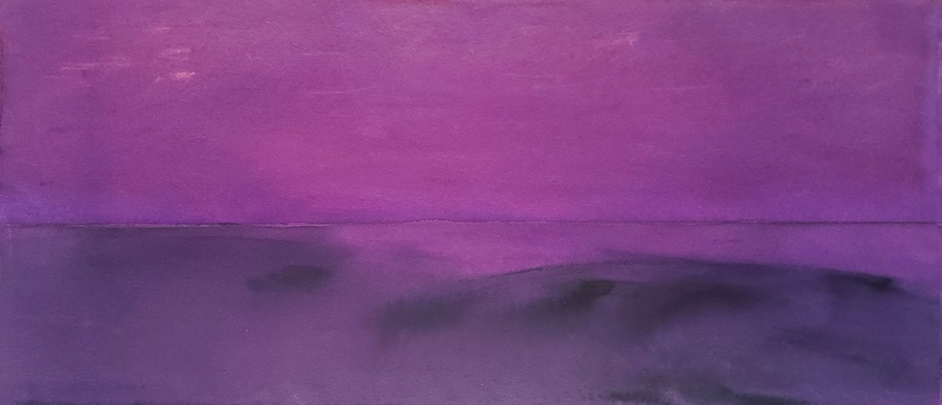

The would-be poets sit docile in their seminars. They draft up their villanelles, their pot-boilers undistinguished from the rest, emotions undistinguished from the rest, the hard words expunged in the workshop, sketchbooks folded on their laps.

They speak of the glories of Homer, the translator with her flawless ethics flawless skin and flawless speaking voice.

You’d think we were living in the 19th century fa’ Crise sake you cried out in scorn to the back-benchers quoting Aeschylus, the Baudelairean brethren answering in their perfect schoolboy French. Shakespeare in their best Edwardian.

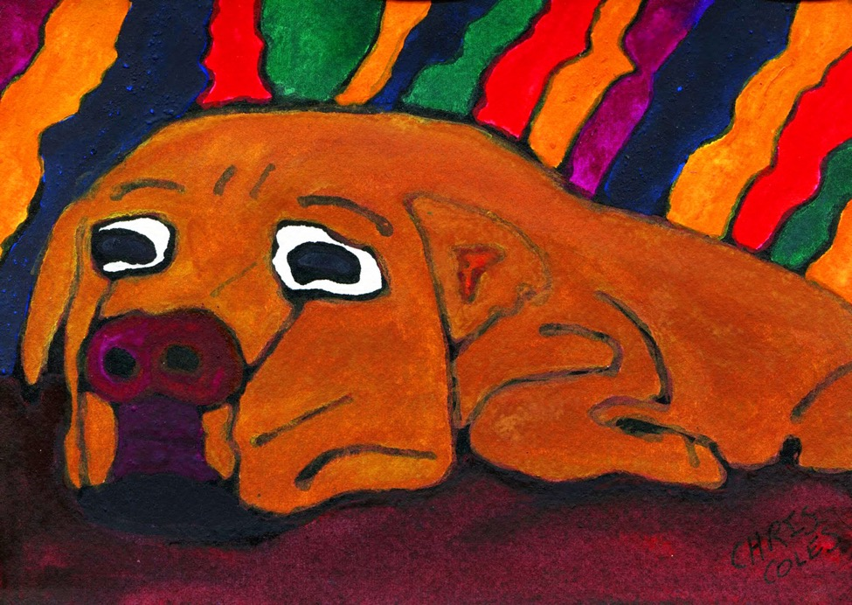

The man in the old red shirt sat shirtless bordering the boardwalk, asphalt in defiance of
the name, a walkway and bike path, all eyes on the seascapes. This man talked to everyone, everyone who would listen, old he was though thirty he may have been or well past sixty; it had been weeks since the dog last barked at anyone.

Food. That’s what he wanted; that’s what it’s always all about. For dogs I mean.
How could you have thought otherwise?

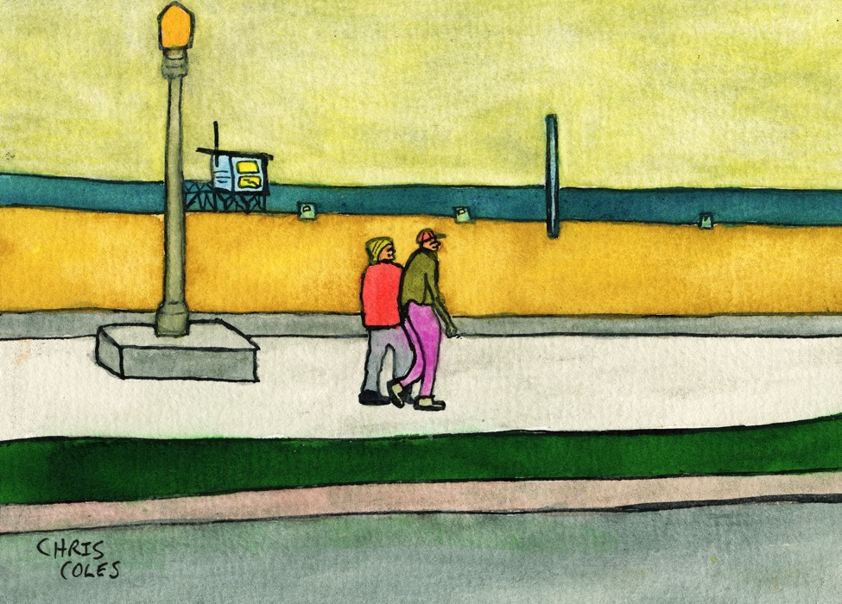

“You two were neighbors here,” the old man said, as the dog lowered its head to the pavement. “His Mercedes, standard ride of the Industry, your mustard Volvo wagon—can’t get more hay-seed professorial than that!—parked on the same street as the celebrated Tom and Jane like in cartoons or names you read about in childrens’ books. L.A. Story all the way, it was, and you passed each other—intent on the same scene, the two of you, schoolmates a decade earlier, 3000 miles to the east, no ice to be found now south of the San Gabriels—each day on the walkway, never noticed never thought twice about it.

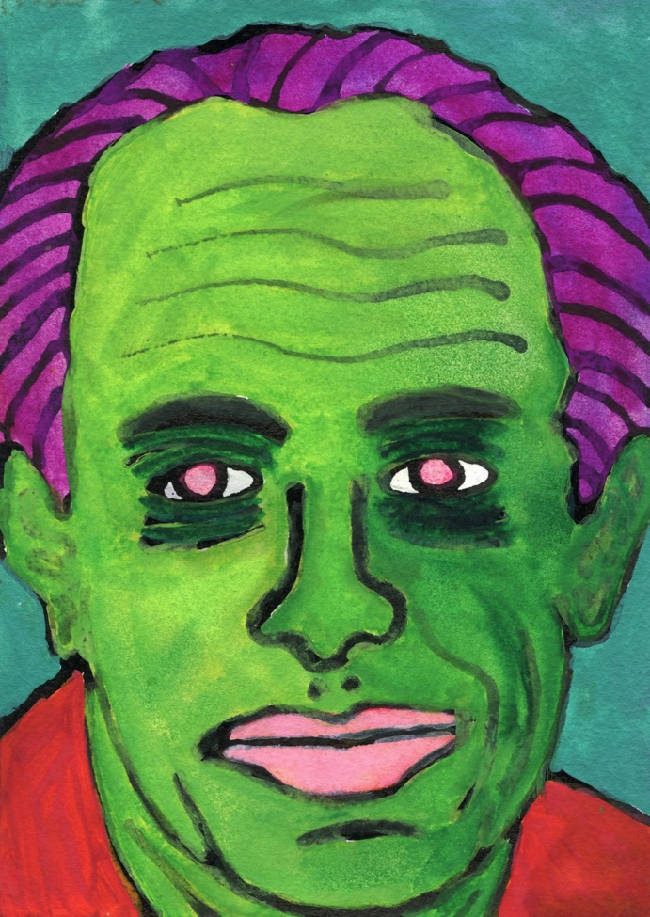

“Bullet there,” he smiled, lifting his pant-leg, “there; a scar in the literal, clinical sense, not the now normal one, as, say, what Auerbach says of Homer in Mimesis.”

“I’m impressed,” I said, letting the language from the old days of sailing think for me, the days of kidnapping crew for the flagship. “Though those who show such wounds I’m told are seldom innocent as words would have them be, say, in the pieties of newsmen or the stilted prose of the police report.”

I know, he said. Like accident victims, the ship vacated at the equinox, the faculty wives correcting their coursework. Like that. All humanity drained out of them.

Nothing left of anything.

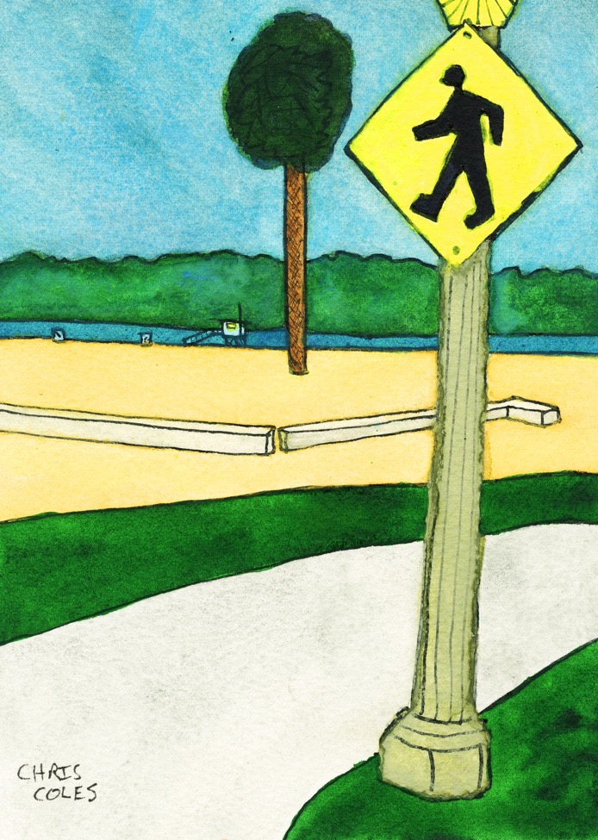

“ ’75 it was,” he said. “Just shipped home. Hardly knowing what to do or how to start, fully crediting the tales of discharged soldiers reviled by hippie welcomers like yourself and when I finally signed out, my hair in place and my back ramrod stiff, stepping carefully into the civilian world, not wishing to screw it all up at the final ceremony, I marched into the street a marked man, I thought, in my green fatigues, and as is the case with most of life, no one gave a shit.

“I lived on nothing. You can live on nothing I’ve always lived on nothing and even you lived on nothing once, unsalaried then or on the stern of the trawler, back in the days when nothing was enough to live on and not just a heady term from a class in philosophy.”

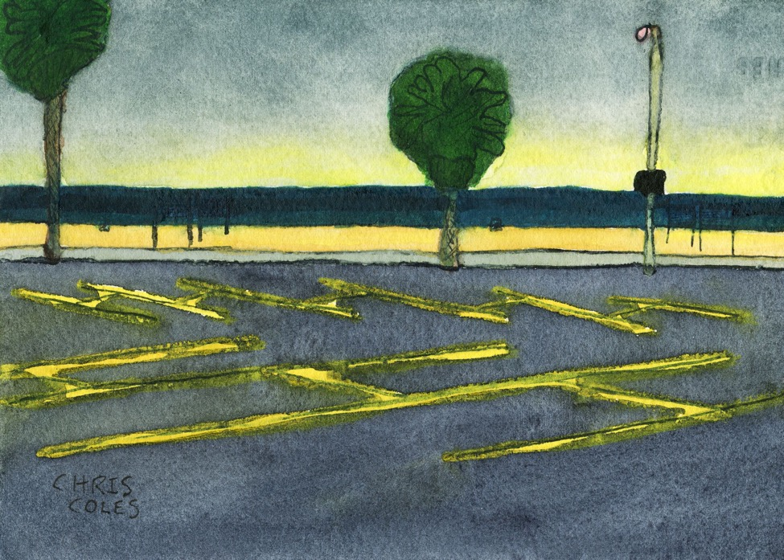

“Every weekend, even through the winter now, the bourgeois families from Torrance or Glendale or maybe from way back East down they come in their Jeeps and SUVs never having set foot off the asphalt; they direct their cameras west hoping for the green flash of the sunset, hoping to tell all about it in the record of the camera lens. No commitment to the beachfront, wanting nothing more from the sand-scapes here, no life-altering experience, only home again in the Valley or back to LAX, thinking the not doing things the same as doing them. All that they experienced all the same, they think, searching for their room keys, the photos of their presence rarely seen again.”

“Like speech bubbles over bullet wounds.“

“Exactly that. …”

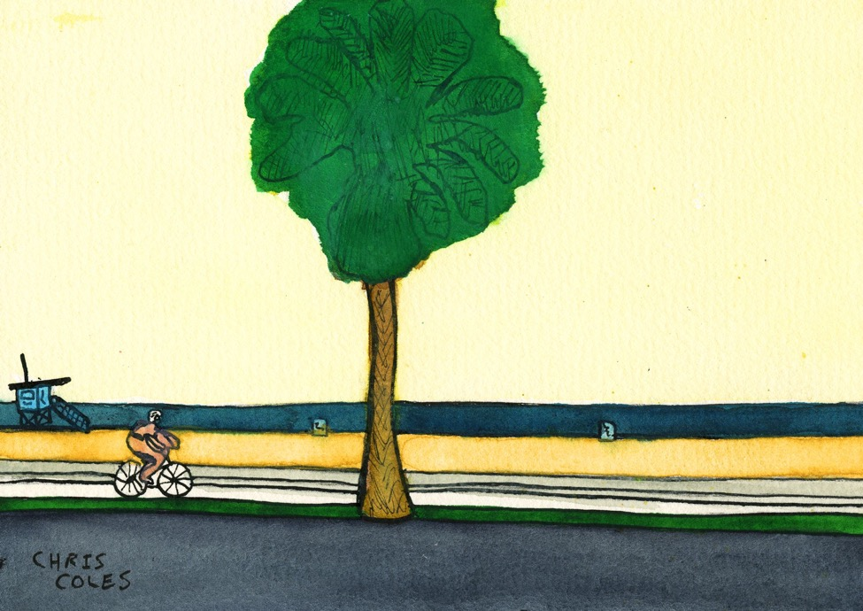

“The nuances, those of the camera those of Feldman, say, all lost to them—mere repetitions, they think, more of the same.

“You have to concentrate and listen twice, I used to say. The chords always variant. The same sun never caught twice by the camera lens. No two frames alike in the appoggiatural burst from the off-shore battery. Nothing but nuance.”

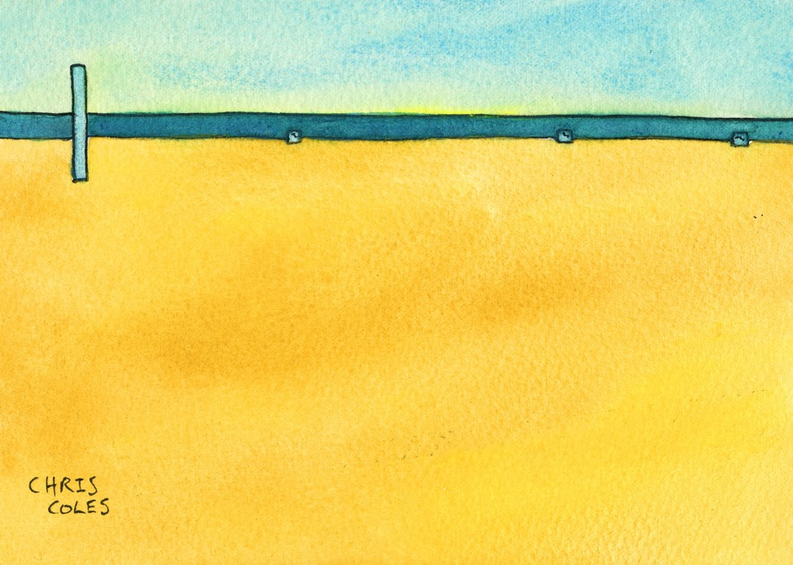

“Quantum mechanics, you see. Oh you know the experiment. The unlocated particles deriding the pious certitudes of the novelists, the unbrooked truths (in the ancient sense) of pipe-puffing professors of literature. Even we learned that when learning the illusory coherence of the self. Or so we thought.

“All those words,” he said, his finger running past where the surgeons cut the bullet out. “Scar tissue at best they are, for me that is,” he added. “Like sweeping the beach debris from Pataya, the soi dogs from Phuket. All that gives those places life. That’s what language does.” He sat back as if relaxed on the worn wood slats of the park bench, layers of paint worked into the grain, each worse than the one it concealed or corrected,
each chipped as the one beneath it, slopped on to hide the surface grain, the grit of the gesso, the hours of planning and revisions.

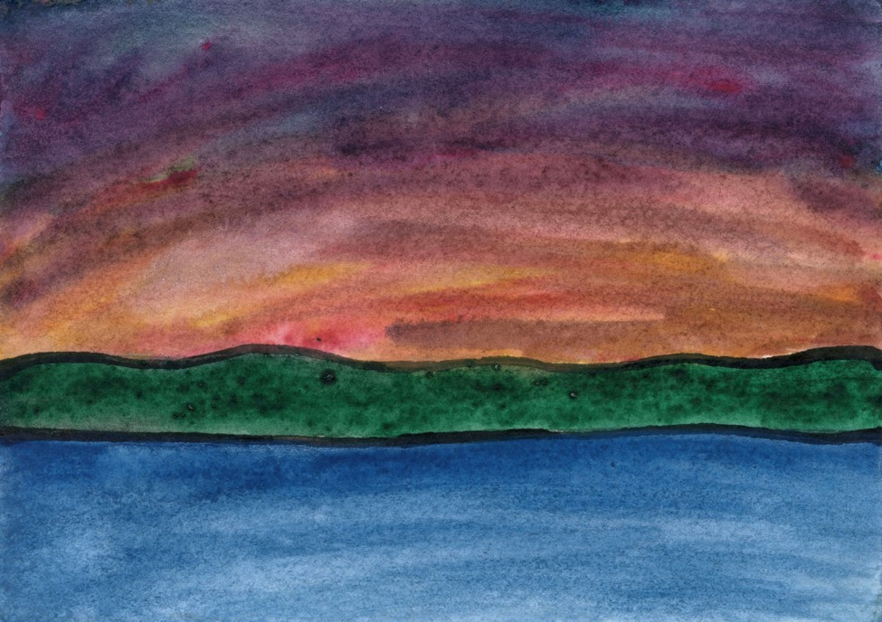

“They took photos of the cities and beaches before and after the bomb runs, no two alike, they said, after the targeting.

“Oh! you said, hopeless pedant that you were, that’s what the bibliographers claimed of the Folger Folios! No two of seventy alike, you said, as they all said.

“As if the thousands of dead cared a whit for the body count. As if flying through the flak anyone gave a crap. As if anyone cared about Shakespeare when the bow doors of the landing craft dropped into the shallows. But you know how those Euros are—always so damn serious about everything. And I heard half the time the pilots just released their ordnance on sheep-fields or jungle canopies.”

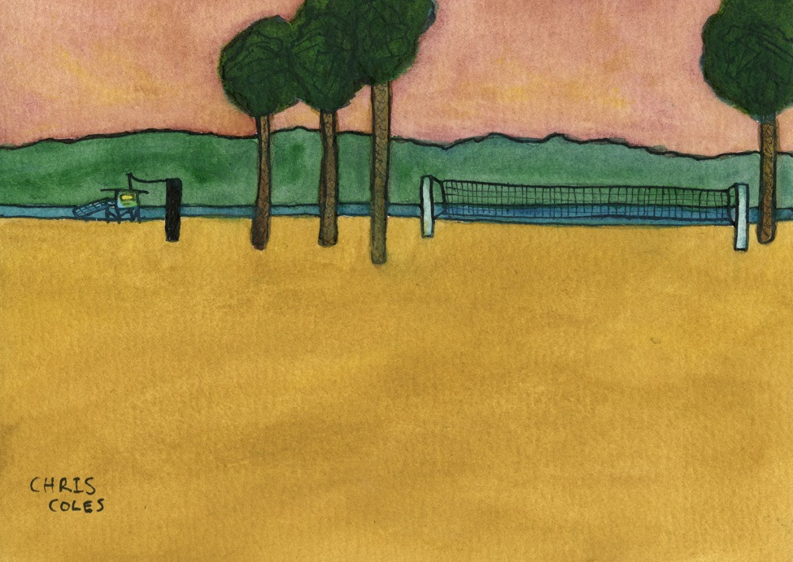

“The light laughed back at me. The ungraspable particles both here and there. The littoral forces scattered in the sun. Nothing but white crosses left. Your lives both here and there in a metaphoric sense. Like pandering for paychecks on the coast, the drifting through the seascapes in summer. The dead cats piled before the old men in lab coats.”

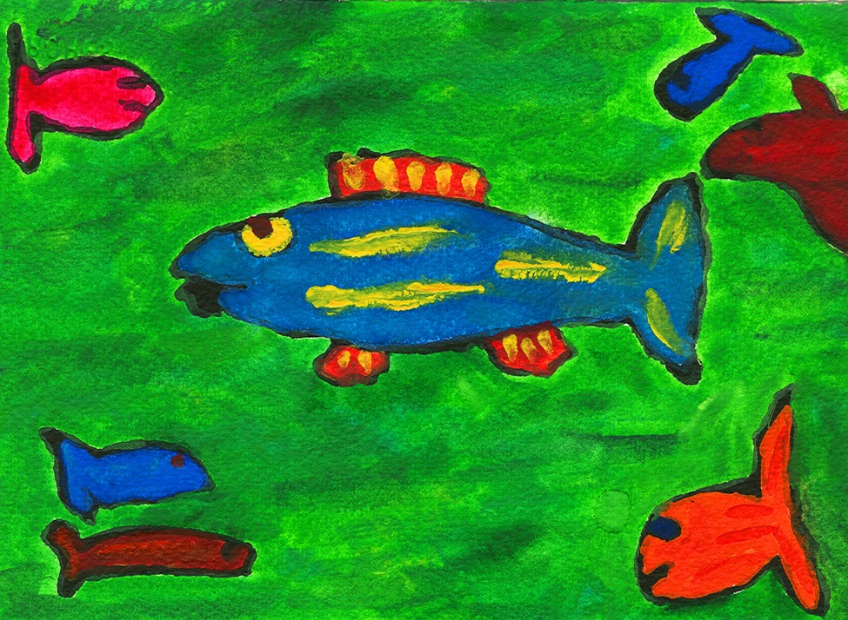

“I used to fish for fish no bigger than the fish that cover the beach on the grunion run in Santa Monica south through Venice Beach and down to Manhattan.

“Sandra, your student once, or student of a colleague once, out there on her piano bench, playing her scales for the grunion run, or one day casting currency out to her listeners.

“They fished the bills out of the sand and bought Jodi Maroni’s on the boardwalk.”

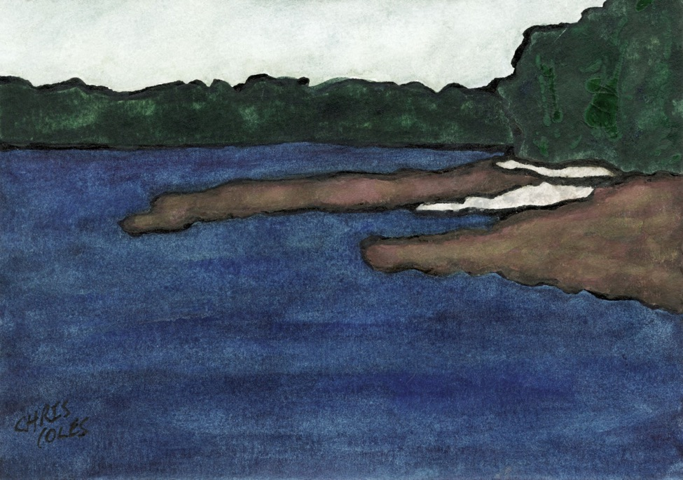

“And then went down to the ship,” as Pound has Homer say, “set keel to the breakers …” raising sail and backing the jib clearing the anchorage the instant the tide turned.

Topsails stowed, reef-points checked, the sails stitched taut by the sailmakers, we ghosted past the last of the ice settled into the inlet.

Deckhands secured the unflaked cordage, each discordant strand reeved through the others. Like the old days they thought, when tales were told properly, when labor and life and our own lives too were cheap.

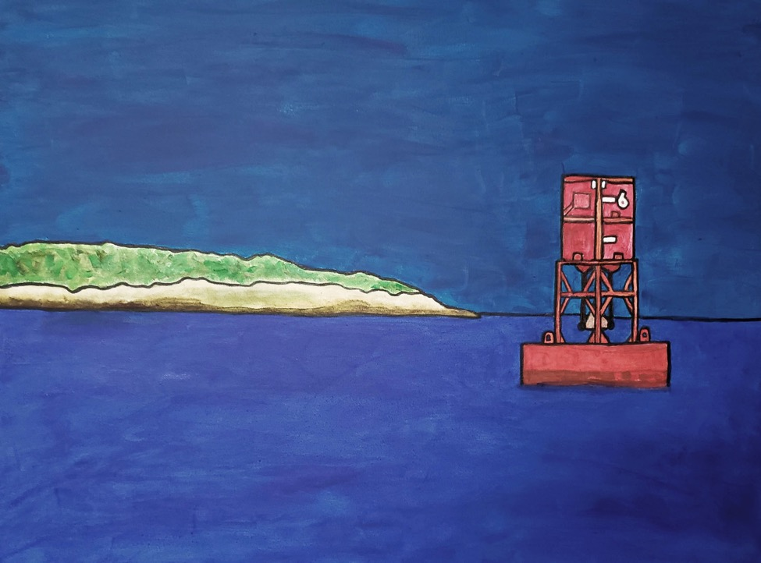

Down East in a week, we thought and so we vowed in the dawn light, as the ebb and the land breeze carried us out through the fishing grounds. Wakeless we were, caught in the current, the working boats still idling at the wharf, loading up with fuel and lobster bait, waiting for the kid who slept late or maybe he had quit on them.

You can’t trust your crew these days, I thought, remembering fifty years ago finding Steve wrecked in the ditch a mile from the mooring, in tears after spending a week’s wage on wheel rims and now the car not worth the salvaging.
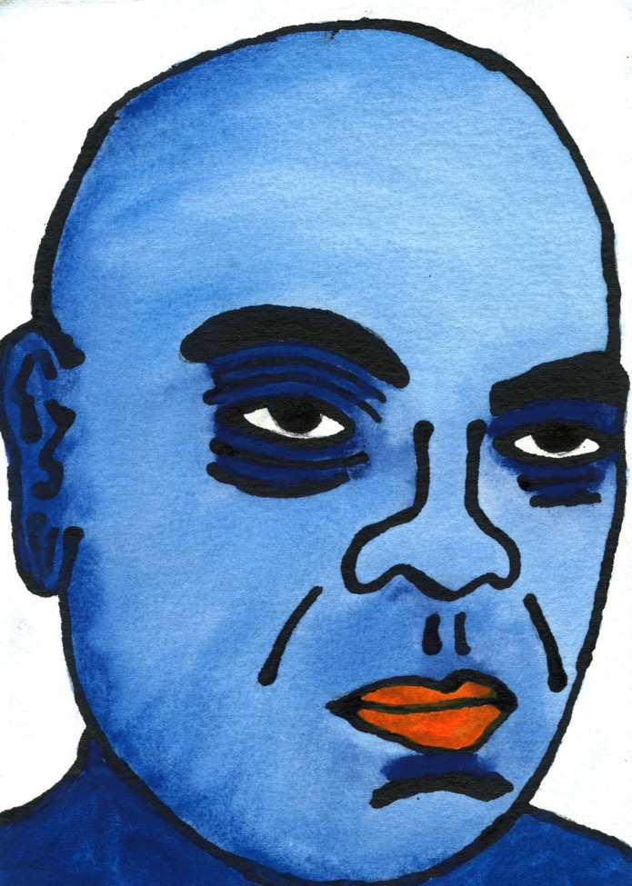

“All the newer boats are diesel now,” the old fisherman said to me, old well before his time like all of them. “Fiberglass and diesel, all of them, even sail, the only wood to be found on the rub rails and combing. No one works with wood now, nailing the planks to the timbers or the strips down to the keelson. No one works on anything. It’s a fucking shame,” he said.

“All those hydraulics too. I’m telling you when the day comes I can’t haul my traps by hand with the n*rhead, well by God I guess I’ll go do something else,” and so he said repeatedly and that day came much sooner than expected, his future closed when the party broke up late and he ran over a kid with his Harley. They cut his foot off, patching his skull as best they could, and he spent the rest of his life in hospice trying to retrieve the sequence of what had happened. What had happened that night after tossing the last beer away, what had happened all the earlier nights, where he had set his traps, back to his childhood, the assault on the au pair from Germany, his ex-wife and ex-friends around him, priming his memories with the sanitized and fiction-like version of them. A portrait framed for the mantle or for the funeral home. Nothing of the beatings, the weeks in the nuthouse.

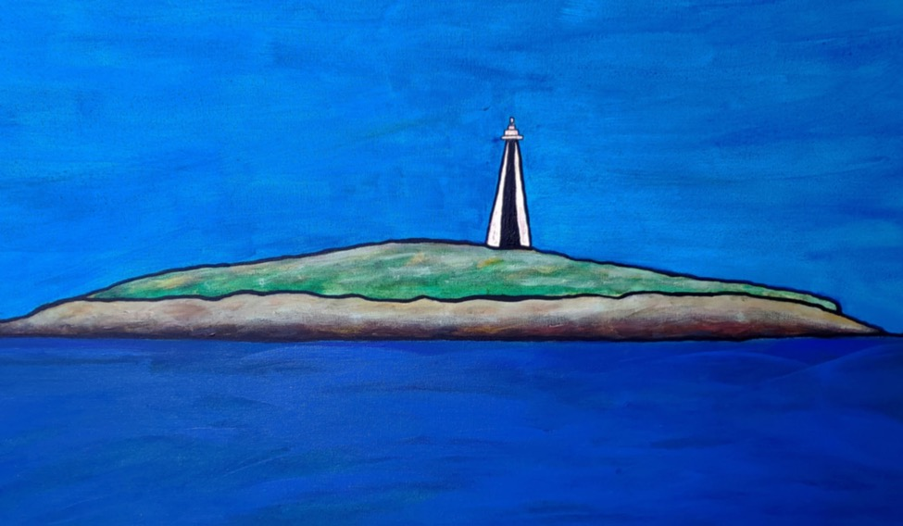

We sailed out to and past the monument, turning from land to the open sea amid the cries of the hawks and the merlins. We fixed our rhumb line, stern to to the monument, swinging the bow east for the bearing, straight shot into the dawn, we thought, setting the mark on Sequin and sailing out toward the Kennebec.

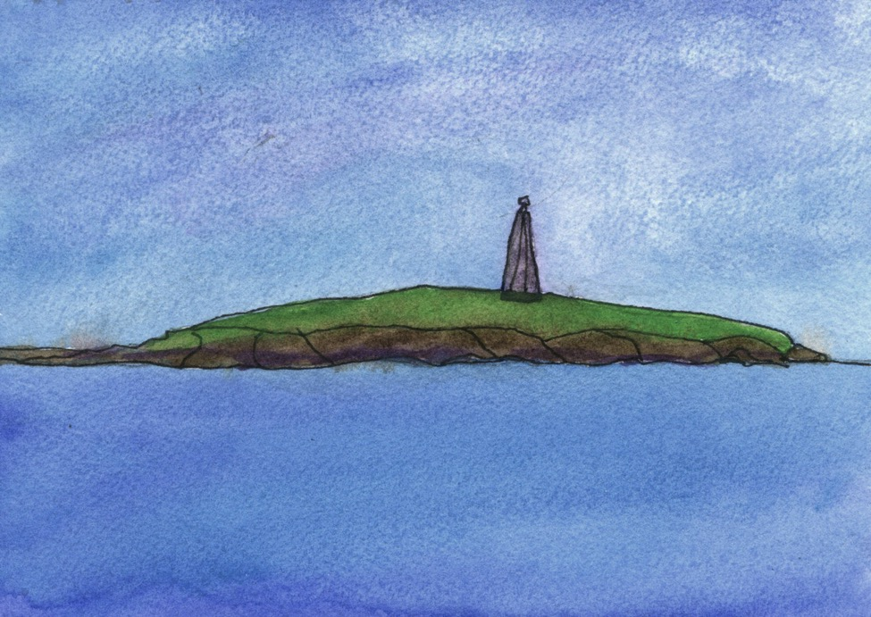

The island faded over the taffrail, darkening in the wake, no longer the same,
just a point on the compass rose, just another variant, one never seen before, consumed in the truths of the parallel rule, our attentions fixed on reciprocals.

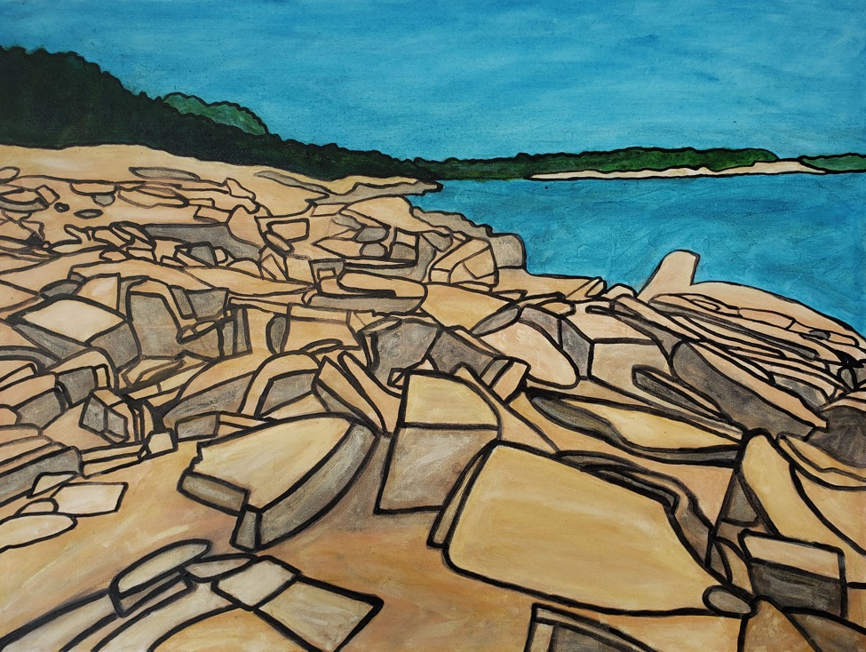

The pilot boat steamed into Stonington towing a line of schooners hauling granite south through the fog of the Penobscot. Just as in the old photos or the seascapes of the islands. We hove to to the wake in the Thoroughfare.

That’s where the cities came from, I said with assurance. That’s where the stones were quarried for the Esterhazy palaces and the storefronts of Manhattan.

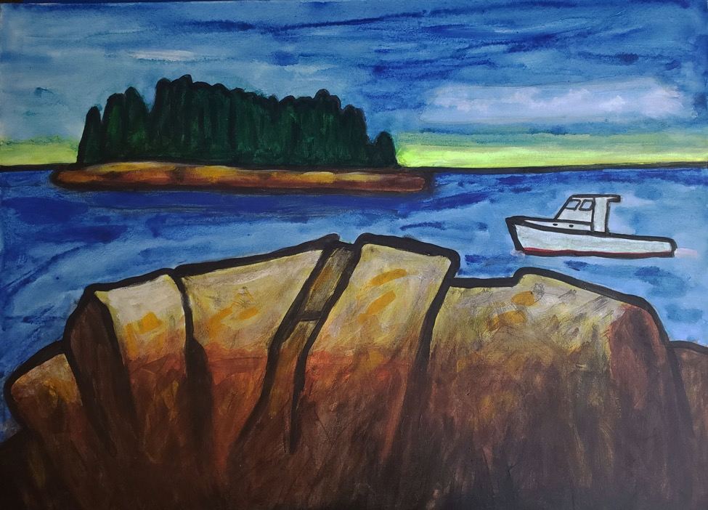
`

We put in at Monhegan and you saw what Hartley saw. What Stevens wrote about: the green and blue of greens and blues. The Gestalt of the rock face.

From the wharf you could imagine Manana treed as it used to be before the Europeans came and turned the islands into sheep fields, before the well-meaning hermit put the shack on it and the walkway down to the water. They still haul dories ashore on the rampway, the anchor rodes chafed to nothing in the sea swells.

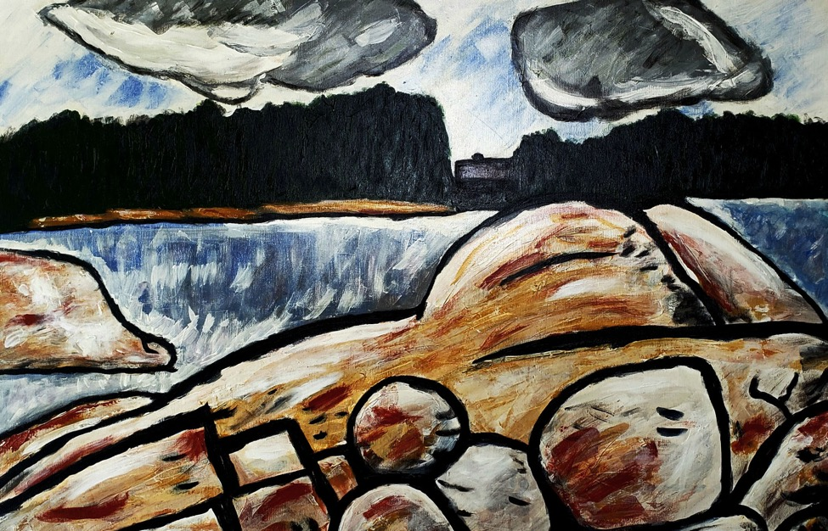

There was little to say. The words no more than items in the lexicon, each clean and unburnished.

All those landscapes and seascapes seemed now mere salvage of hours at the easel lining the walls of the gift shops from Kittery to Calais, snapped up by the tour boats by the cruise ships, tacked to the hotel corridors, the walls carpeted in the style of the eighties.

Neither as an artist nor a lover would you be one of them, not one like the others. All the flesh and ambience and it didn’t matter who or what you were thinking as long as lying back you could think back on it, the hands of the clock face, her turning slowly toward you, her face in profile.

It didn’t matter that love was done to death. Like all of it done to death.

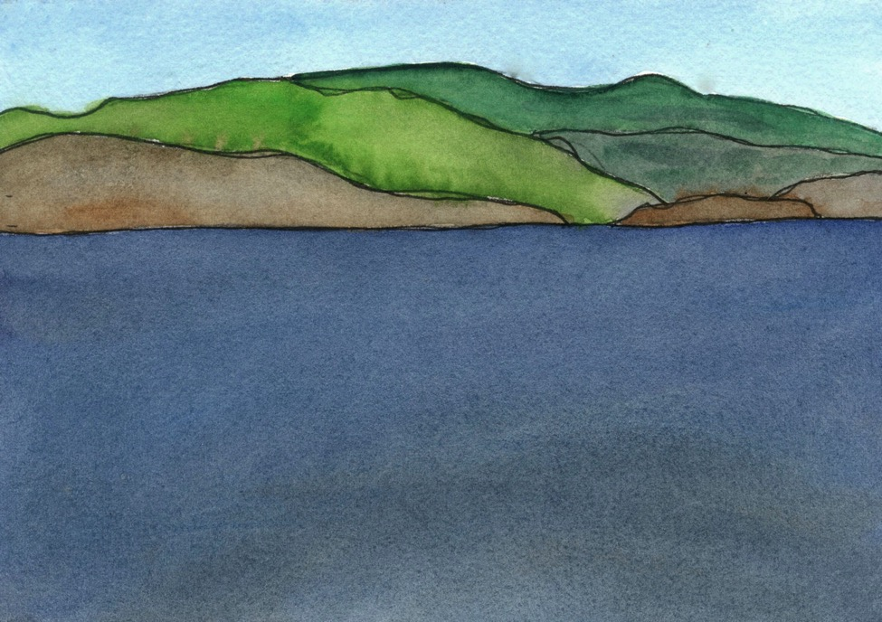

And she became the landscape now, afloat on the cloth-waves, as if isled onto the sea-surface. The weight of her arm across you, her lips pursed as she lay back and stared at the ceiling light, her face now shrouded in the night-shirt, its green now folded about her, Stevens’ moon, he thought, wrapped in its purple cloak, whatever that meant, whatever he meant by that, her face embraced by the duvet she insisted on, those Proustian jeunes filles at the beach resort in Normandy, so like the others, so unlike anyone. “It’s a sad thing,” she said, rolling into the blanket, something about back-pain or maybe her asthma, “when a girl has to bring her own bed,” and it was at that moment, that moment …

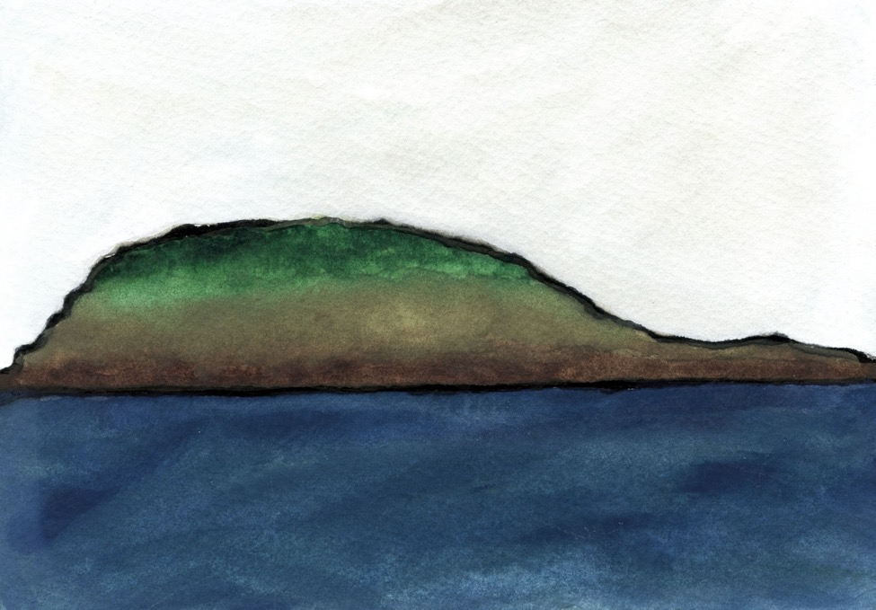

In three days we reached the island known as the Ladle, Down East in the literal sense now, scoured as was our track itself by Fundy tides, landing not possible, just off Cape Split or Eastern Harbor or whatever other name seems unknown to the Coast Guard. But you know what Feynman says, the Ensign, trained in obedience, said in his defense, he always said: “If all you know is names for things,” he said, “then you know nothing.” Those Adamic namers never worked as cooks or galley-slaves, he added, Pot Rock to the north half the size of the Ladle that serves it; they never hauled water through the waist-high snow from the well-head as your once-captain did.

The tide poured through the salmon pens out from the anchorage in the north bight of Trafton, darling of the cruising guides; and once the fog came in we didn’t see anything, none of the growth topping the island, none of the rock line marking the spring tides on the neap tide, none of the blue on the water. Just the monochromal greys you see in the old photographs or the ice fields of the Arctic.

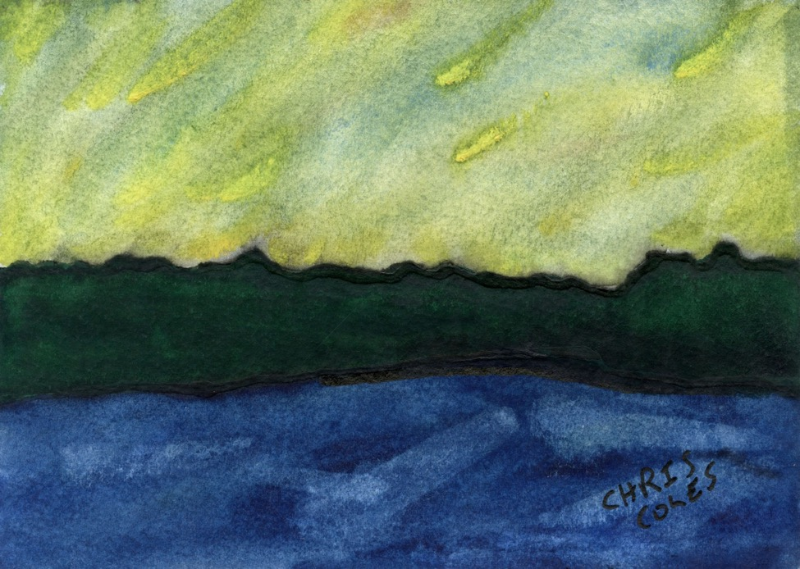

Remember how the aurorae broke out that day in June, five years ago? or maybe it was just the stars in their Luciferian luminescence early fall during the Perseids. The sky was alive with resentment as the light passed over the tree-line. The sea-life lounged in the shallows.

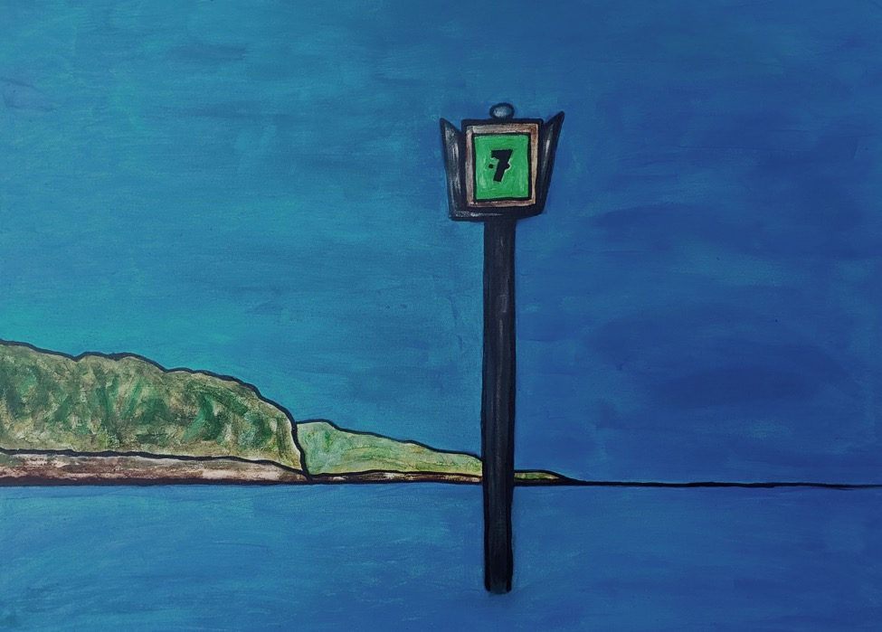

On the seventh day we all paused as if for rest, waiting for the tide in the lee north of the spindle, just as the old schooners did in the harbors of the Penobscot, hull-down with feathered granite as ballast, waiting for the current to proceed through the channel.

Fit to be tied, we were, and I told Berkeley as we bound his hands to the mast or to the hatch-grate and called the crew to witness punishment that there was nothing personal about it.

And I said to him as he pleaded his innocence,

“This is nothing,” I said, parting the cat braids. Forgetting this, he would learn this too.

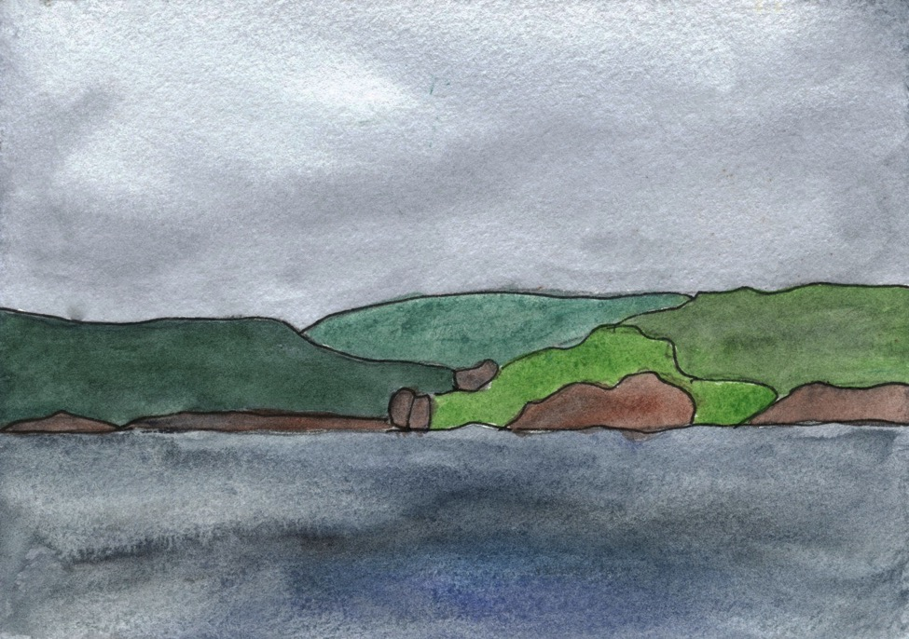

It was when she said “I realized then there was no path, no course for us not sailed before,” exactly then the fog pushed over the island shrinking its radius around us,
the ring of fog tightening in the fog, nothing to be seen nothing in the universe I thought
or hoped nothing but her face as I lay with her against the starboard rail, our shoulders braced on the combing, thinking not of her but of sailing past the buoy off Haskell’s
just west of the monument, caught by desire no way to make it back to the harbor and making not quite love but the façade of it, looking into her eyes as I turned from the fog knowing the commercial boats could steam up upon us in an instant, “making their day,” they would say when they realized what was happening before them, their captains reading the sea-floor from the instruments, no concern with boats emerging from the fog, their lovers mere clutter on the radar screen.

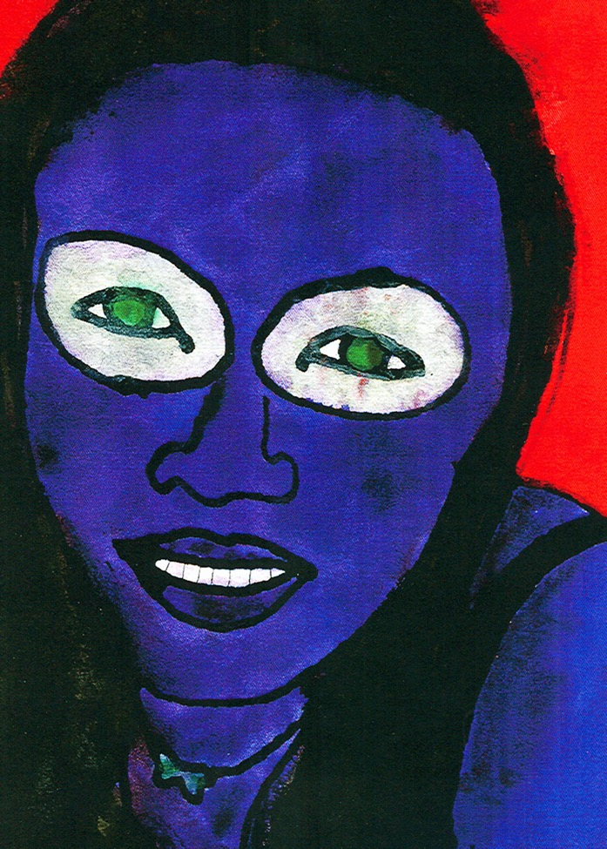

Do not speak to me of the mermaids the fishermen lost at sea, the sea-seen frames of the seascapes.

Even the Coffin boys could not keep their composure, three days searching with the divers out past where the ledge breaks off Jaquish, wailing to the newsmen, crying out pieties for the reporters in foul-weather gear. “A tragedy,” they said, knowing no other word for it. Fit for monuments or the writing of elegies. All the while the body of their kin tangled in the weed of the rock-face, the eyes pecked out by the seabirds, the flesh no better than lobster bait.

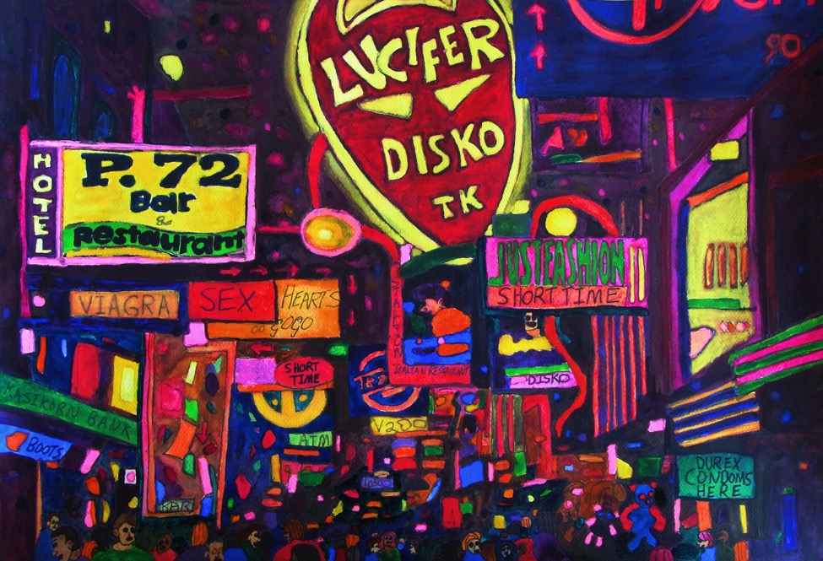

Forget the assignment, I wrote on my paper, half-done for you; for how are you, some tweedy professor, to judge my comparison of the hell-scapes of Milton to an S&M club on Hollywood Blvd when you have no clue what these places are or like? You, whose notion of the exotic is the empty beach at Venice Beach south of Santa Monica or maybe how the traffic circle south of Kittery half-way to Boston seemed to you as a teenager.

You saw my poodle skirt, carefully picked from the consignment store, the kind of thing today found only at Swing Dance venues, and thought Oh yes, just like those innocent and wholesome girls in grammar school, forgetting it was 1990 not 1955 and it would have been like showing up in a flapper dress to your prom in the 60s. Barely twenty, my body all plumped out like a kid with baby fat, the flesh pumped full, the outlines demark this and clearly that, like the cartoon shapes of the knee-high socks and skirts from the fifties.

As valediction “Love, Liz” I wrote, traced in blood, adding my phone number, and you were so unraveled you completely lost the plot, as your Anglophilic friends might say.

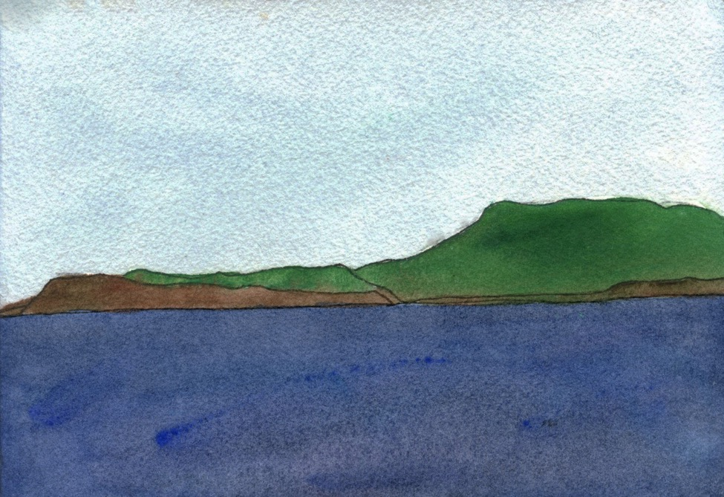

That’s what you shut out, you see, you the academic with elbow patches, me with the burns from the cigarettes still dotted on my thighs. Track marks up to my elbow, bite marks everywhere. Life for you was sailing then, like the time you took me out, out on the water, my eyes fixed on the land masses, life in its sudden simplicity.

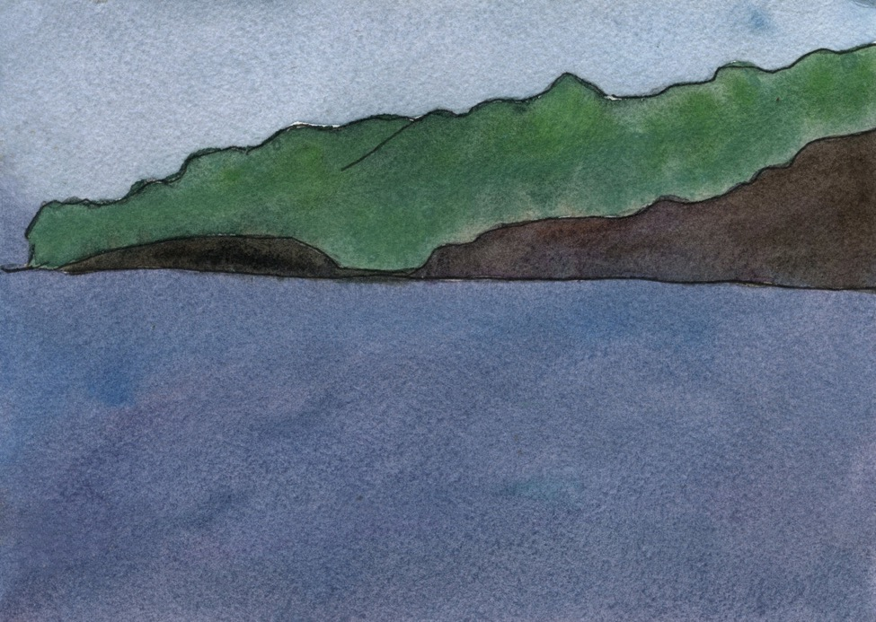

And this is when you said to me, again you said:

You sail in air, you said, over the land, the water lifting you over the loft of the sea-floor to this, this view of the island, East shore of Ragged it appears to me, where Edna St Vincent Millay once flashed the fishermen and my own captain went down in the open skiff a version of the old fishing smacks of the 19th century and his helper hugged the hull, wailing, the water sweeping over the gunwales, crying like a child as his boss dragged him thrashing in protest to shore and no no never again, he cried, never on the water again it took three men to get him into the Hampton that finally came ashore to rescue them.

And years later, you were calmly fishing for lobsters out in the fog when the Hinckley went down, almost within hearing distance, holed fatally on Saddleback lost too in the fog far from their dead-reckoned course and the parents of your classmate got their last look at each other helpless in the indifferent sea. And you wrote of that, thinking nothing of it, thinking all would do, thinking you had found the precise wash of irony and grief, that smug unfounded pride of the bad poets before love refashions everything.

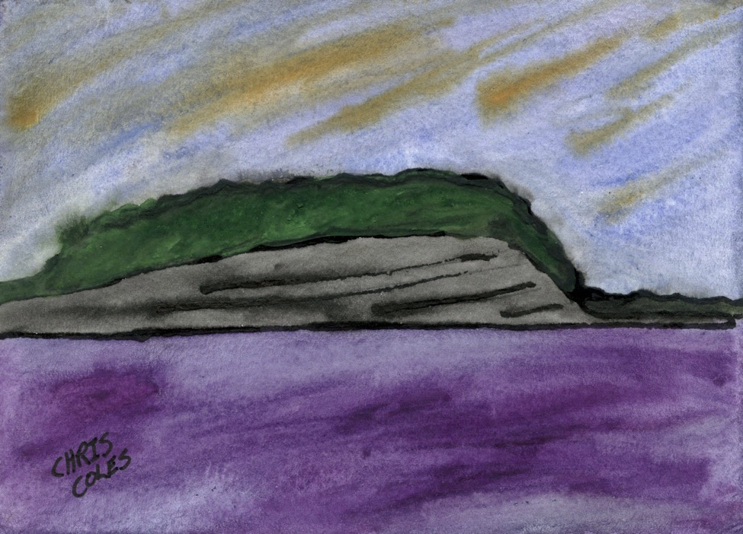

I was gazing out to the crowd when the drugs hit and my gaze became the haze of remembering being out there on the water with you, staring at the colors of the club on the Strip refracted in the haze, no more shocking primaries, everything awry.

I reached out, you know how it is, you feel faint amid what I called the “clouds of unconsciousness” once, and you laughed and struck through the phrase with a blue pen; a highlight or excision, what’s the difference? you said. Speak in whatever voice your true voice is, despite the cuts on the wrists still visible after weeks in rehab, the nights waking up wondering whether you ever consented to this.

The colors folded in upon themselves, the blues reddening to something never seen before, the striations of the rocks impossibly reflecting the light in the distance and I rubbed my eyes and looked again.

The second look, you always said. That’s the key to it.

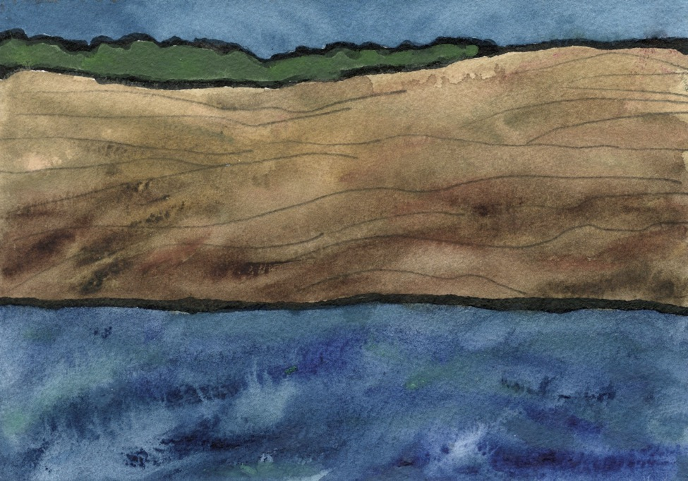

Rose lay down now stripped of her life vest, her face in her folded arms and turned away from him, unseen and to the right of the picture frame, to the left her legs absorbing the sun, and all the morning trust in him, trust in him as a sailor, trust too
that he would cover her fare back to Manhattan, all of that relaxed into certainty, remembering the movement of the hull feeling the illusory warmth of the opiates, as he bent over her and began the back rub she demanded, slowly starting from her shoulders and moving down to her hips and she whispered something absurdly affirmative like “I have to keep my virtue, what little I have left.”

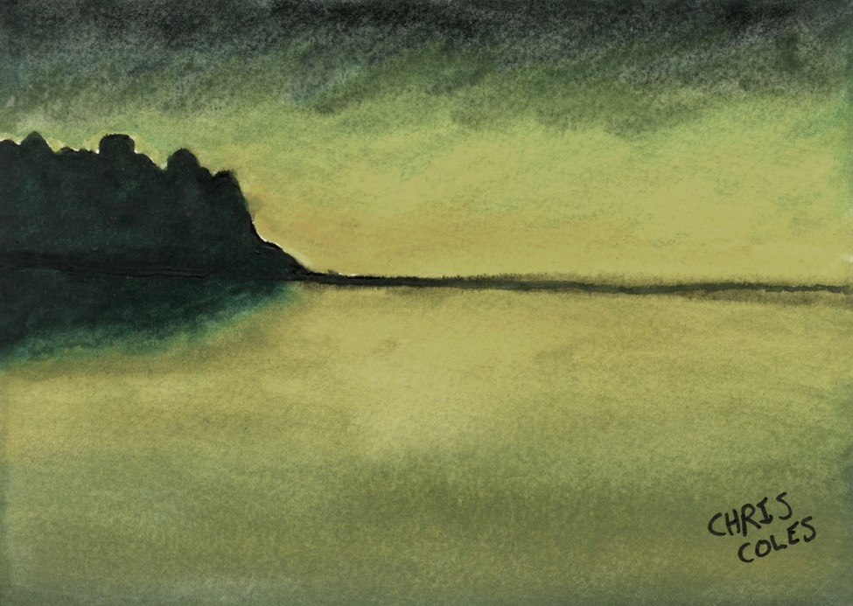

Near frost, it seemed, that evening in October when you stood tall you say on the north-facing porch, the boat now hauled for the winter, hearing the wind through the century-old spruce or it may be the water itself, a sound source out past the boughs of the treeline. A night scene then, the light from the distant town scattered in the fog. Owls or the loons wintered over.

It may be April, but more likely June on a sailing trip, the quiet is as June on a sailing trip, the summerfolk indoors planning their weddings and reunions, plotting their cuckoldries, or still piled up in White Plains or Connecticut. Or mid-winter, say, when they are gone for good and the residents holed up with their wood-stoves and heat-exchangers.

“Or it may be simply you,” I said. “Pure grace you always were, sunset or dawn or perhaps just facing the storm edge.”

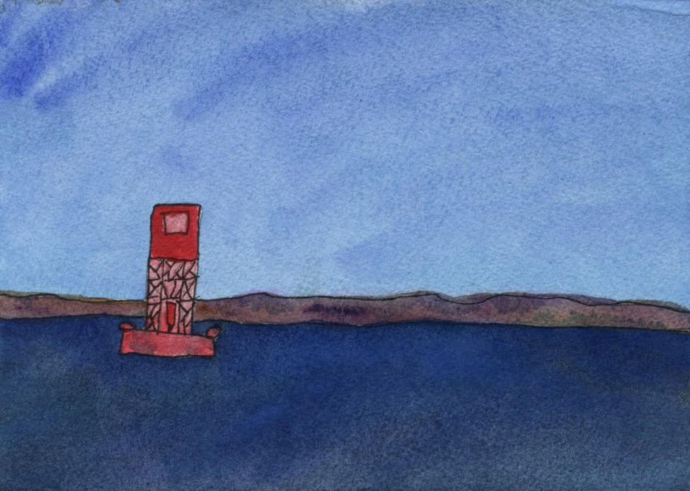

I was sailing out of New Harbor and I heard again the voice of the Dominatrix, quoting the last book she read with me: “The things that made us loathsome as teenagers,” so she said, quoting from the book she read, “those are things that make us loathsome still.”

I was sailing out of New Harbor, passing the buoy bent in the wake of the tour boat, passengers braced on the hand-rails of the pulpit, ogling the sea-birds, out rounding the outer islands of the Muscongus to the Penobscot, dreaming of Eloise, who never came to Maine, who never walked the beaches of Los Angeles, and I took her down to the jetty and stared into her face in the rain and it was another face staring back into a rain-soaked face and ‘This is such a bad idea,’ she said, the new face said, all that hedonistic stuff I missed as a schoolboy, the very word she used that day.

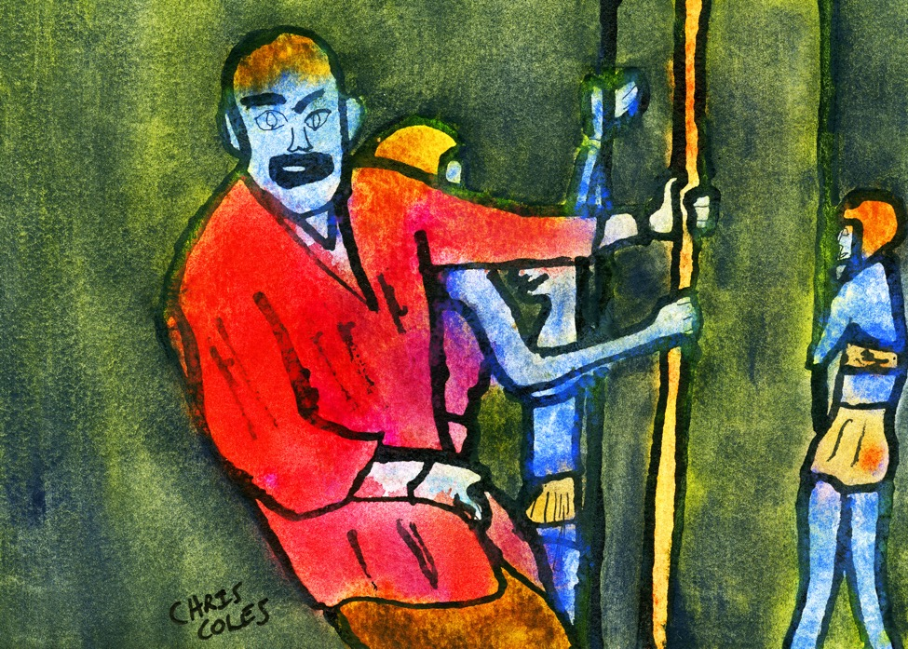

She left her job, remember?, pole-dancing in the club in Hollywood, or maybe just took the night off, and off you went for coffee somewhere past the canals on Venice Blvd, the open-mic singer in the front room, fat and neglected in one of those sack dresses of the fifties, even her friends hiding their faces in embarrassment, the band your hot friend sang for in the back with that country twang perfected in a school back East, Swarthmore or Sweetbriar, and you pulled her to you introducing her a drug-addled soloist to the soloist. So much for authenticity, you said, your karaoke wit lost on everyone.

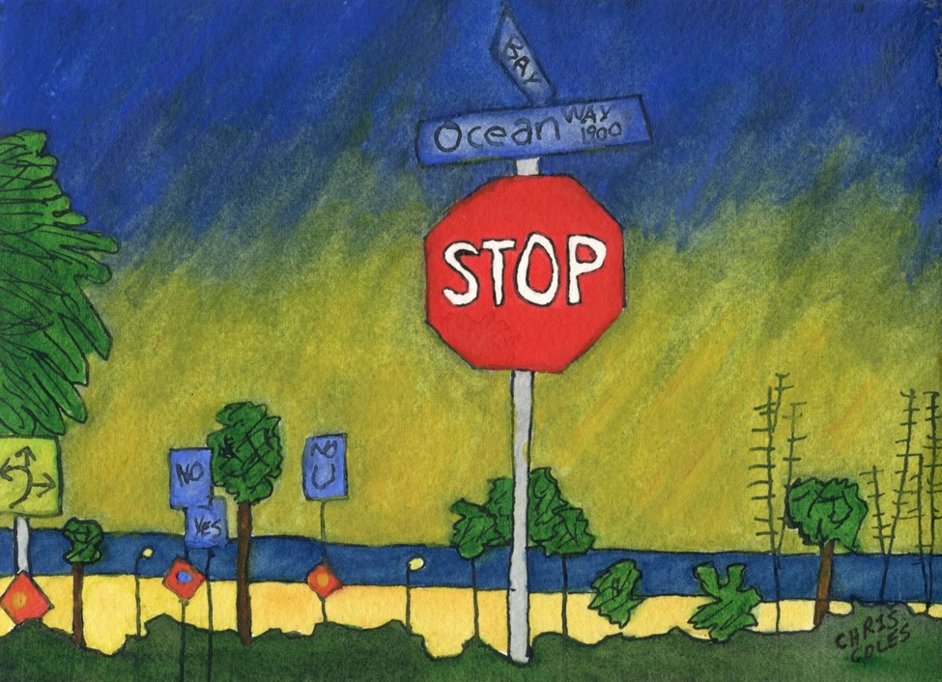

“Don’t even think that we are dating,” she then said to you.

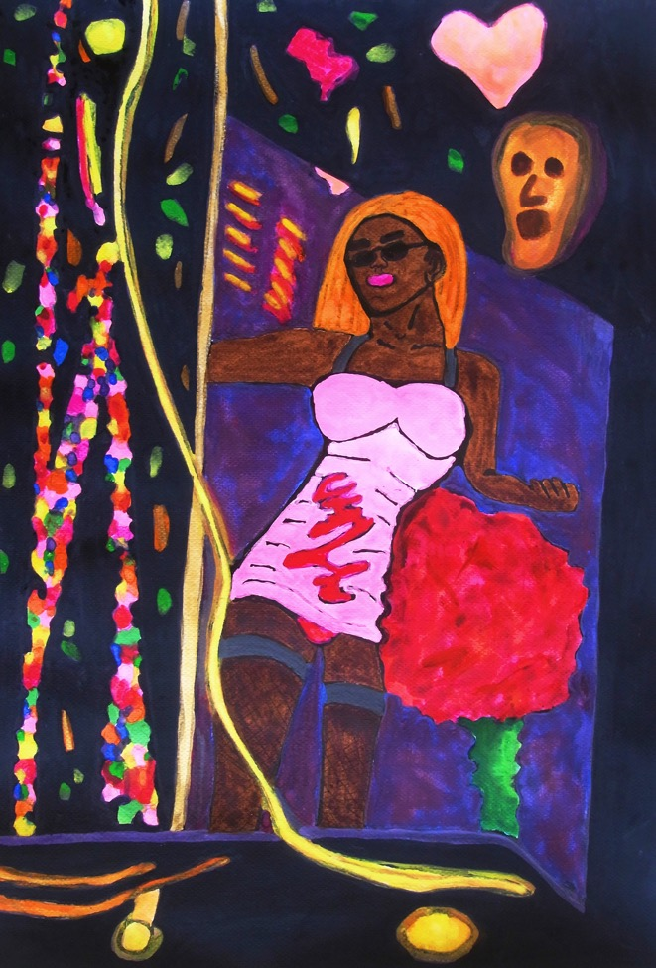

“Oh I don’t dance,” I used to say with conviction. It was a “thing” from the old days when I thought not doing things itself a thing, a Ding-an-sich as the Kantians would say, or maybe Sartre served all that up to me: flying, dancing, eating Sushi, sailing to the Asian East or West, all that existentialist fol-de-rol—like margarine straight from the tub, as those women once-removed would say.

You cannot sail the course you plotted on the sailing chart. Nothing free in that, I said, nor in your words she grumbled from the keyboard, the shapes and colors fixed in pixels of computer screens.



I was sailing out of New Harbor when the swallowtail flew past, surely the spirit of Eloise, her most recent lover said, and there was nothing I could answer him.

I was sailing out of New Harbor and I sang the admonitions of the Dominatrix deriding my love for Eloise.

Could have been anyone she said could have been “they are all the same” she said in mock contempt as we bent over our sketchpads in the studio then laughed thinking then what I was thinking. “Every one of them, every part of them. Glazed with costumes and condo fees. Brush strokes and the bold colors straight from the goddamn can, as you once said or used to say, that’s what life is, so you said.”

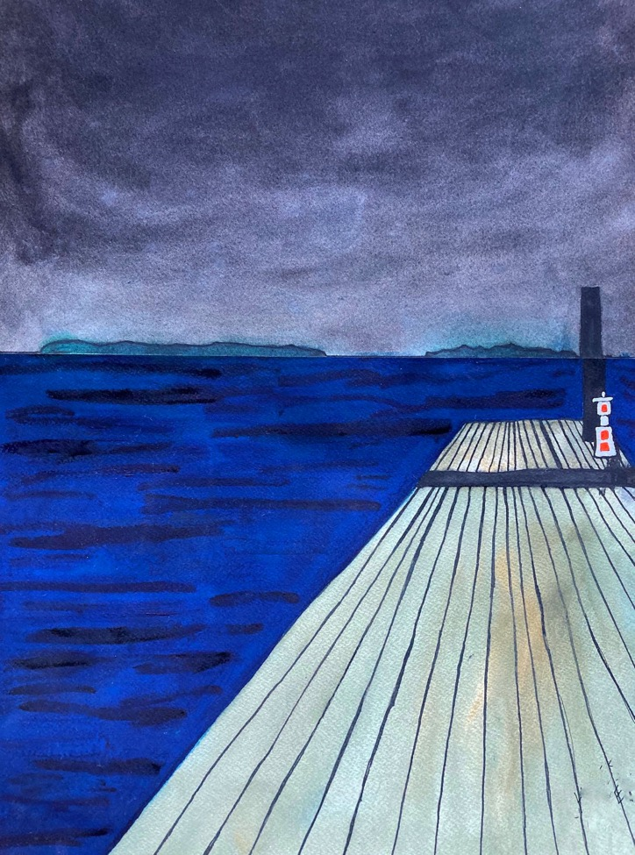

You sail in the shallows, you love poets do, (that old sonnet commonplace straight from the hornbooks), not off-shore with the big boys as Virgil and Homer did, as Jack the philanderer once said of the epicists, all those commissioned sculptors proudly far at sea, hailing the three-decker novelists all deep draft Aschenbachians, hailing all the book-prized writers of their lives and other lives.

You do not sail, that is, with true pelagics, far from the evening anchorage, far from the safety of soundings, every swell a swell you’ve seen before.

That’s what you once said to me, I think.
Everything I think is what you once have said to me.

Fin

