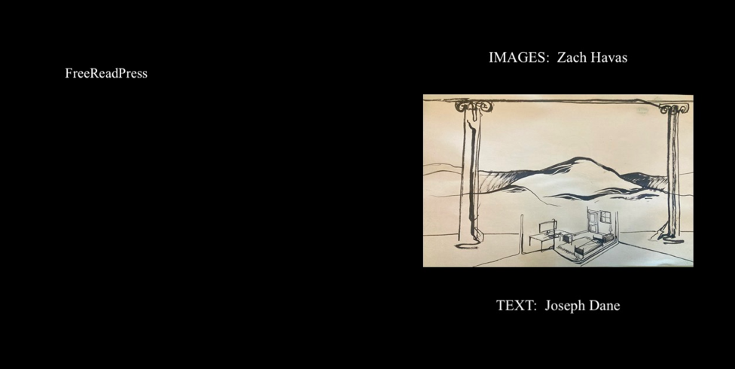

If possible, set reader to two page view with this page as verso: in first chap., images will thus be on left.

IMAGES by Zach Havas

TEXT by Joseph Dane

Copyright © 2026 by Zach Havas and Joseph Dane
All rights reserved,
Harpswell, ME: FreeReadPress, 2026
ISBN: : 9798195462659

1. Ground Rules

2. Life Lessons from the Cathedral

3. To the Fishing Grounds

4. Misgivings of Middle America

5. Tundral Steppes East of Kodiak

6. Sandscapes

7. Laudatio Temporis Acti

1. GROUND RULES (I)

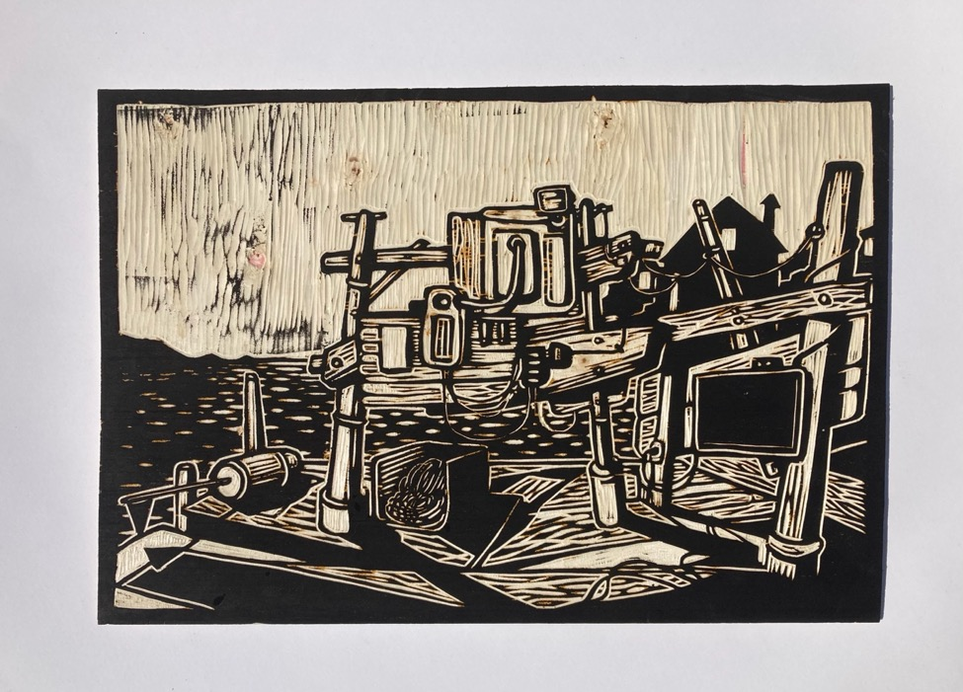

We woke as custom, barely light. I never dreamed the ramp would still be slick from the bait fish trucked in from West Point, near Malaga.

The light drifted slowly across the cross beams and the tide held slack at the zenith. I rubbed my eyes, the scents familiar but unplaceable–1968, fishing Deep Cove, a mile off Cundy’s; or buying mackerel by the swing bridge at Kennebunkport in the 50s; or last year, Cashes Ledge, sharing a bowl over the bait box with Toby …

Nothing was as is or as it should be ought to be or always had been, so I thought.

I looked again as shadows formed and fell now west: these seascapes still not seascapes I had ever seen, ever known or experienced. The starkness of contrasts; the strict demarcations, this and that.

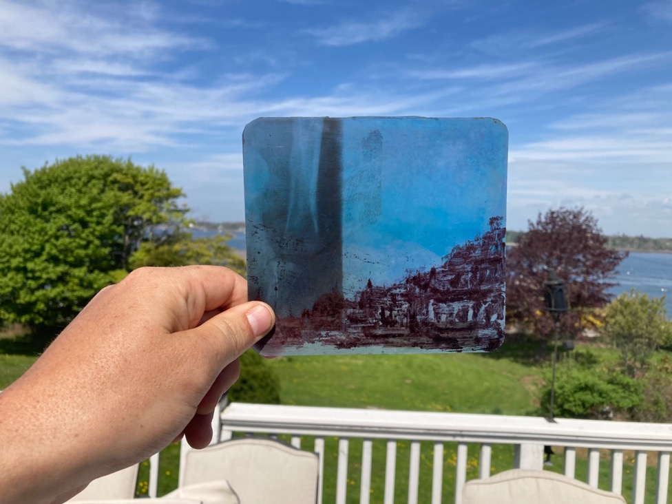

Colors near to gone, it seemed. Like life drained out of everything, n’est-ce pas? Or all that I thought constituted life: art, music, THC, and the banality of sports cliches.

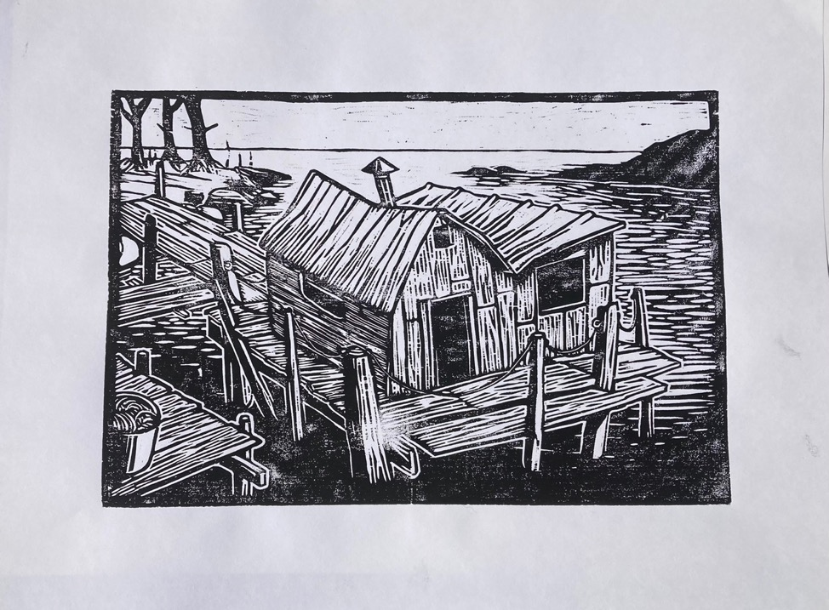
Are there presumed things outlined in those surfaces? the cynic in me asks. Land and sea. The trapezoidal salt-box roof. The buildings même. Or are those rather mere perspectives, fickle like medieval landscapes or images of cathedrals—blueprints at best, not icons in a strict nor any sense—a world of nothing you could see ... Or grander yet like Plato’s “forms” or “ideas” in the wrong but vulgar sense, real things then, I guess, things only known in a dream state.

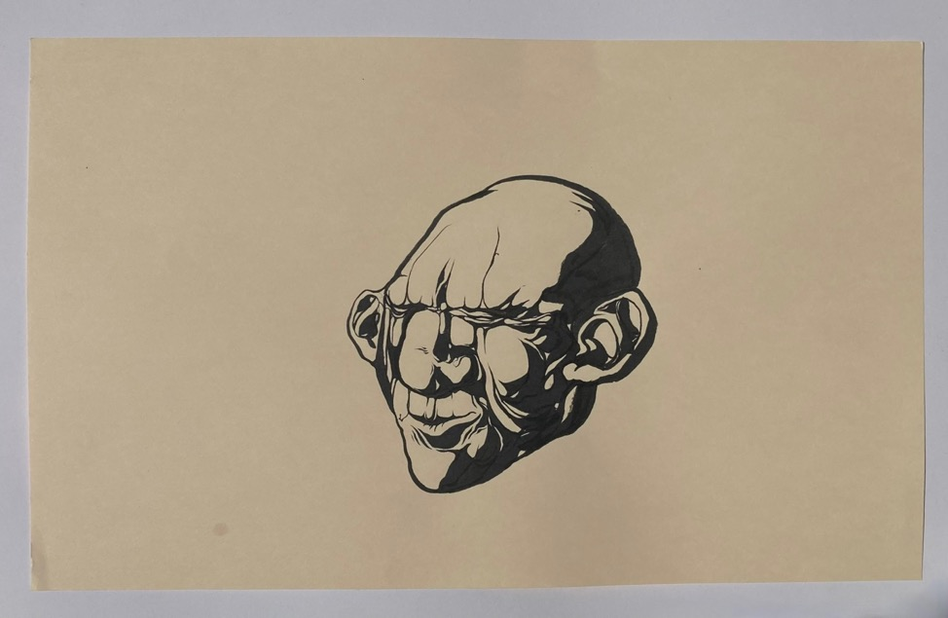
And then “You have to see,” I heard you say, your face coming slowly into focus, a professional now, with stern face and a lab coat.

“2 AM at your work-bench–a reconverted walk-up on 114th Street, 1978. Remember that? drifting off sketching the article that would one day bring the academy to their knees in wonderment? or maybe that novel scenario imagined in your spare time or even in your sleep, as you would insist on awakening?

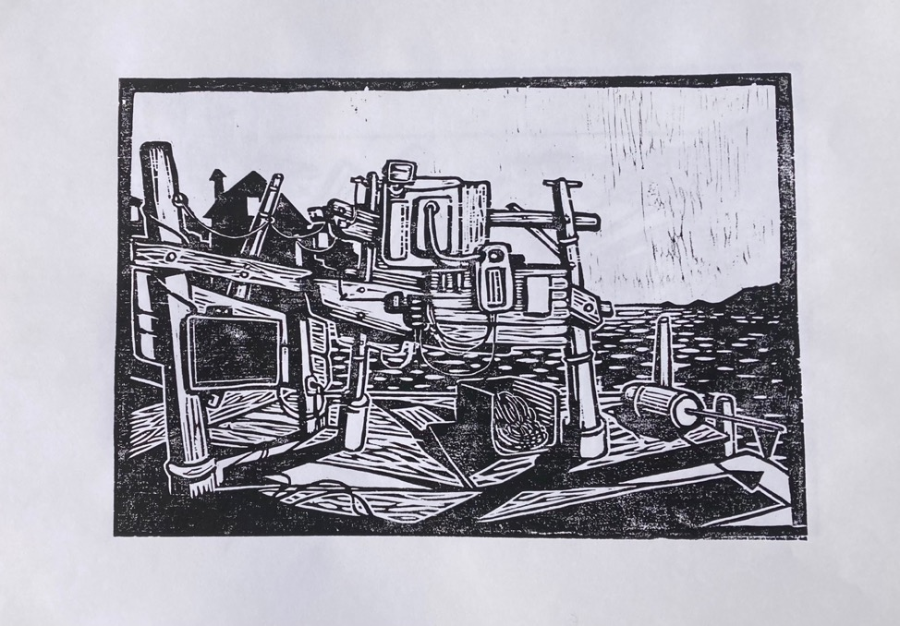

“All is now as it always was. All of importance. The house and work-shed in perfect order. The chimney venting gasses from the woodstove.”

The wavelets lap now on the timber frames, the inlet clear to the open sea. All is as it always was, you used to say to me.

“Do not be fooled by the tidal shifts,
the irregularities of the currents.
Nor by the crass illusions of the self.”

Ground Rules (II)

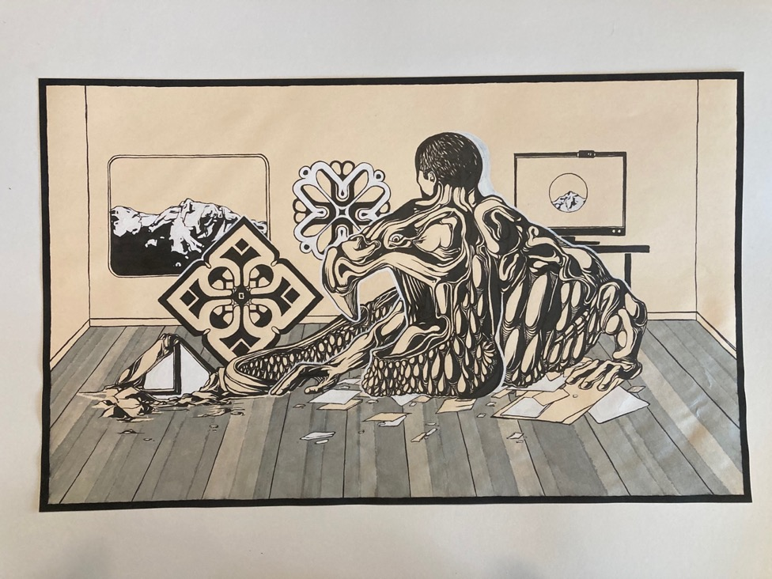

There were days those days we dined with the Solitaires
top of the hill in the old colonial
just where the road turns south
and skips down to the colony.

That’s how I would state it best …

Playing at gentlemen or maybe landholding gentry seul.
Dressed in our best suits,
best pieces framed up for the best display.
short-cuts to culture lining the bookshelves.

That was class in mid-century America,
The last one of course is meant.

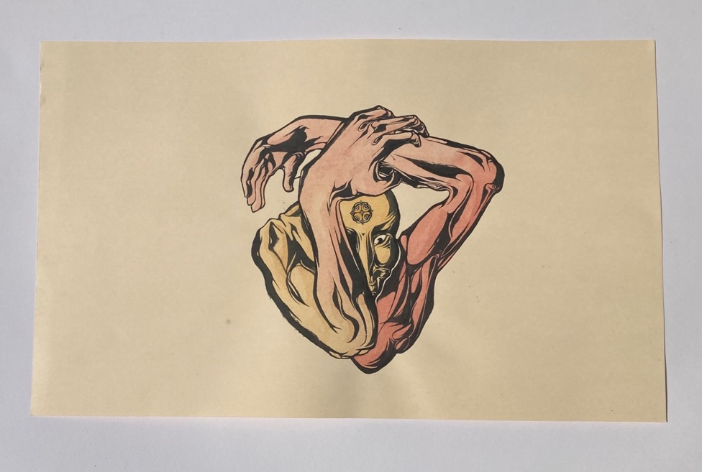

And there were also nights seized with night sweats, love and hate: love when that dreamt life unfolded in what seemed, at least, like history; and hate as all came to nothing. “Terror on the Rocks” you entitled it, both the lived event and emblem here, arms bent in righteous and yet sinister defense.

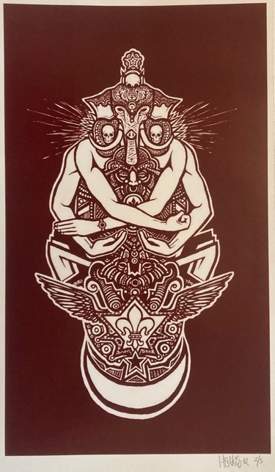

And now out of poetry, I asked the sage directly, seeking direction from one who did not care what direction is. Just this, I said: teach me the essences, the whatness of things, the truth, we’d say, beneath these ontic shufflings of …
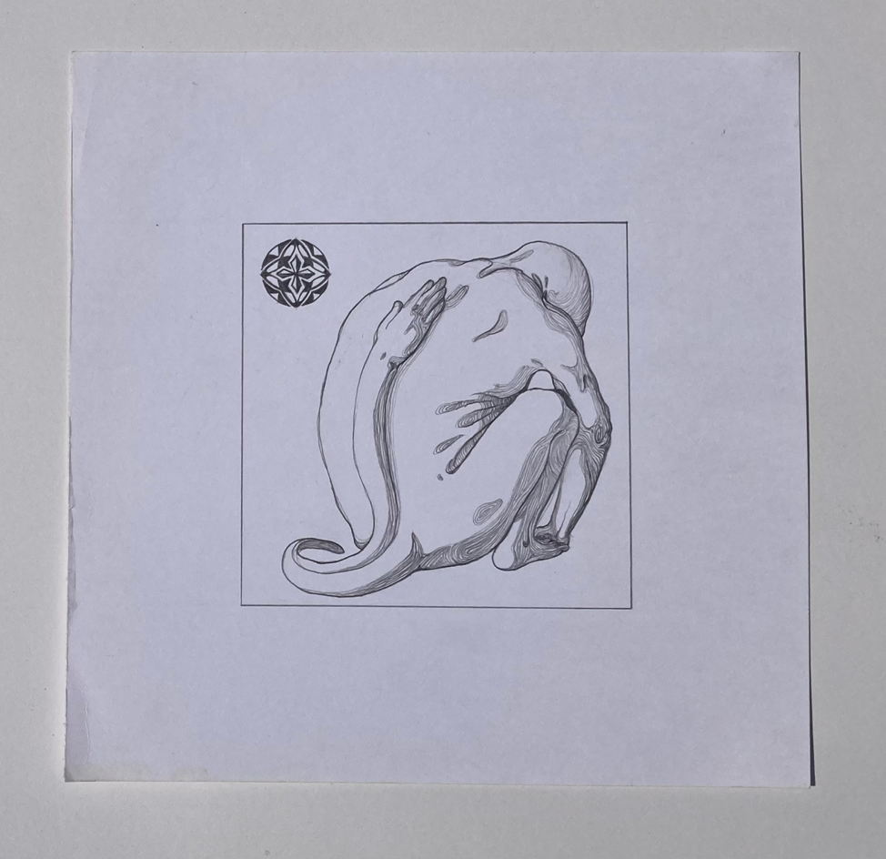
But you just laughed. ”Enough” you gently said. “Did you not hear?”

You have to see it through and see through it as well

you said, slowly and deliberately, enunciating the final syllables evenly to give no hint as to what was or could be meant—to make the dictum heard as simply hearing print itself.
The factotal absolutes of life,

you said consolingly. I hear it clearly now as I did then—

all that apocalyptal phasmagoria: It no more is than you.

You have to see through the superfice (to speak in equivocals: ‘ignore’ or ‘use’, if you will). What does it matter which army you march with? or who dances, say, upon the pencil edge? You have to see through what you see. That’s the key.

2. LIFE LESSONS IN THE CATHEDRAL

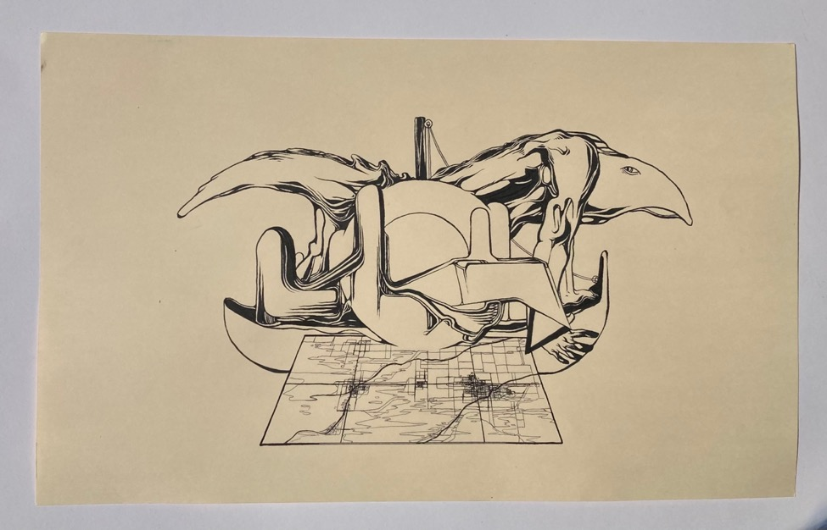
Remember Paris in the days before satellites? You simply moved as the Michelin Guide demanded, A to Zed, (or is that the London version?), all streets in a codex in any case, monument to f*cking monument (as Gabor described it), or cutting through Rue des mauvais garçons to Rue de Rivoli (shibboleth of uvular fricatives) feeling like a bad-ass cosmopolitan. You prepared your question, even the synthetic scrambling of the lexemes—you know how it goes: you breathe deep as you imagine natives do and in your studied schoolboy French you ask directions in an elegant interrogative, never thinking that in this alien world the more fluent the query the more argotic the response. Better not to have asked at all, you think, as the priests drone on in their vestments. It is with life as with art, they say: just stay lost.

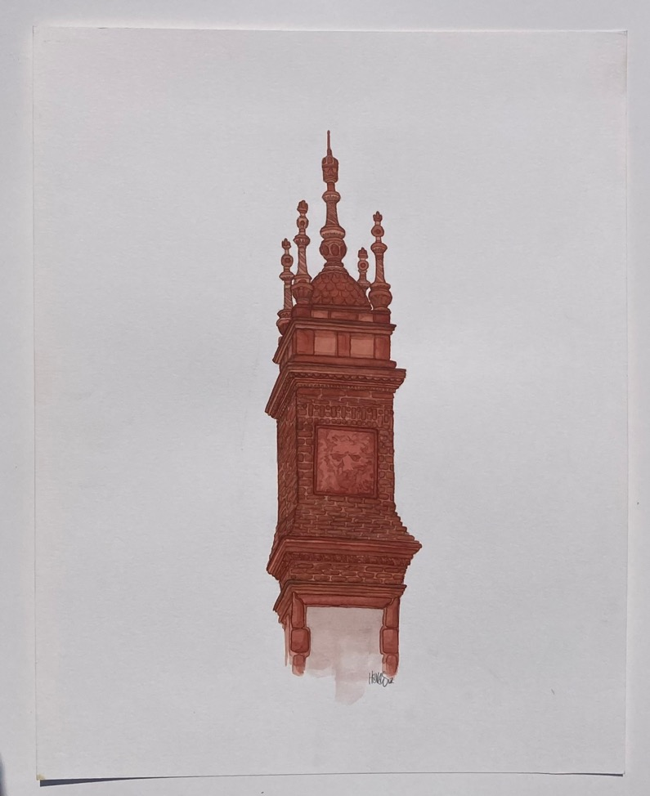
Of course, every snot-nosed schoolchild or rank amateuse of local history knows what any errant tourist experiences: Maine has as many steeples as the whole damn ancient continent, each town rising from the mist with peaks like minarets or old four-posters, Kittery to Damariscotta, and every small town from China east to Calais.

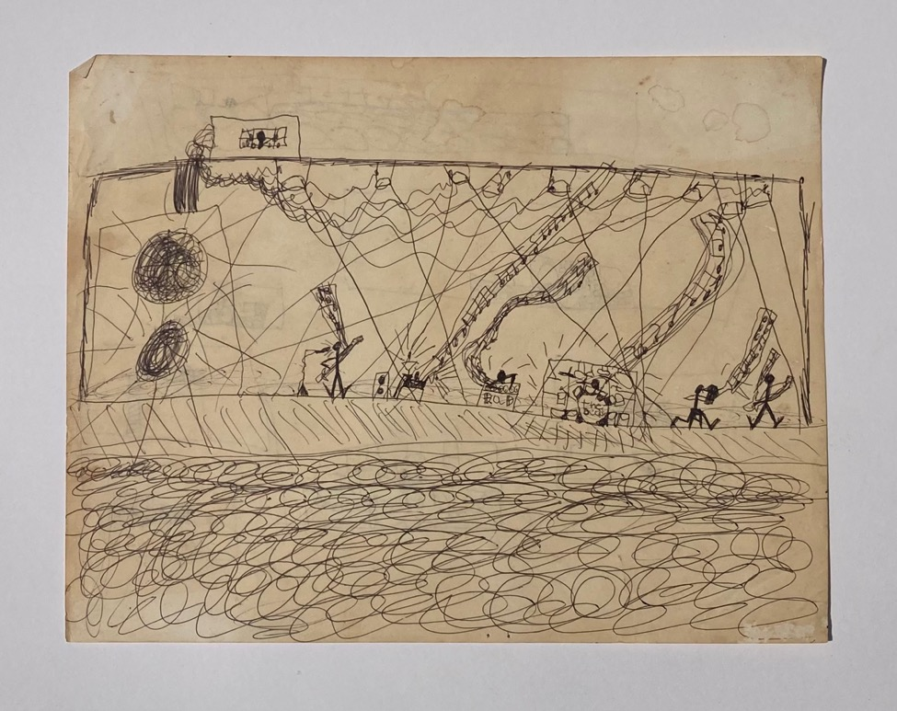

Locals went there as families in the old days, on Sundays when dads were home. Attendance they called it, a sign of virtue or seriousness of soul, I guess, investing all in Sunday best, piety, and Bibles you could steal from cheap motels. What did it matter? You raised the hymnal when instructed. You stared at the staff, Marshall stacks like flags of our enemies, singing only what your seat-mate seemed to sing as the celebrants swarm to the exits.

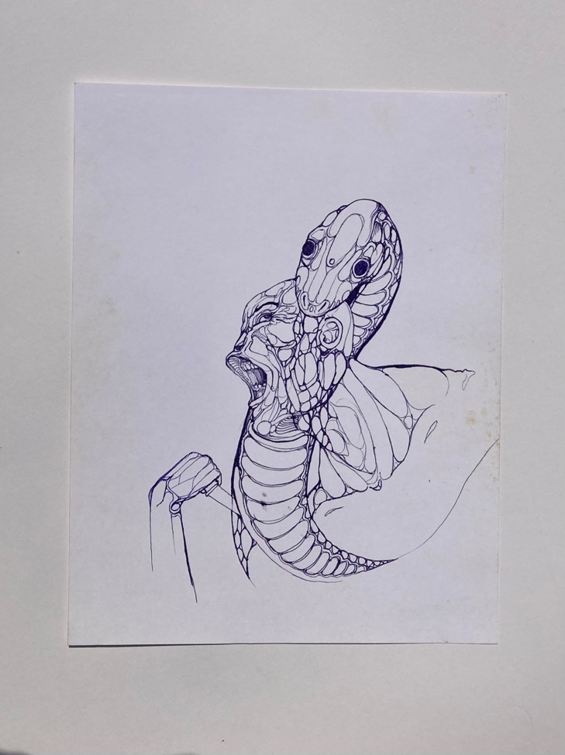
All those old saws! the pew-stricken morality and the Boschean torments of hell. No one believes that stuff today and few believed it then. What good was it supposed to do?

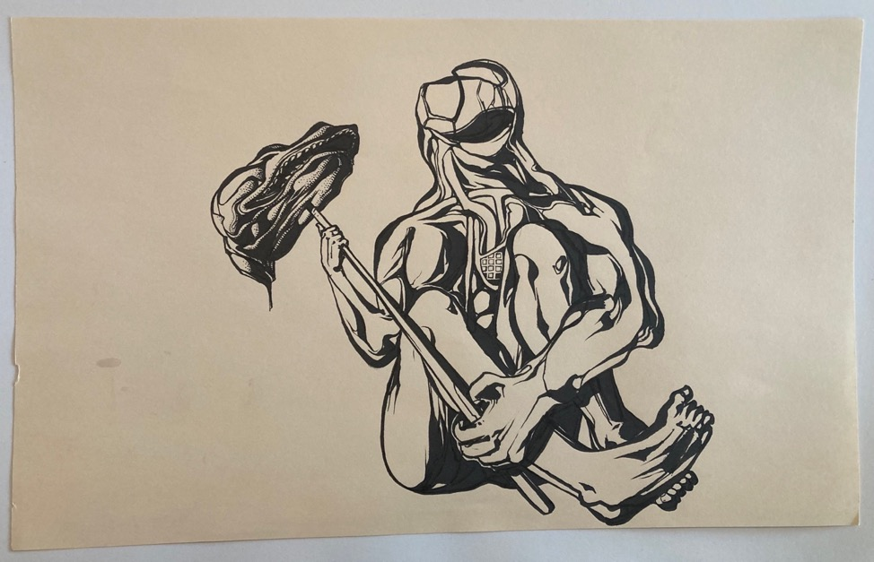

Oh, do not fret, they all said: the world is your oyster (whatever that meant). Doctor, rock star, Indian chief, they said; it’s up to you as the Bildungsroman of life achieves its end. Scrivener, companion to Europe, entertaining gentlemen with conversation. Pike-bearer. Breaking rocks with wild men on a chain gang in the Muni or Paul Newman film. Just check the boxes containing a boat, a motorcycle with a sidecar, an old Passat. As if all that mattered were the priestly accoutrements you chose: make-up, costumes, getting laid at the wrap party.

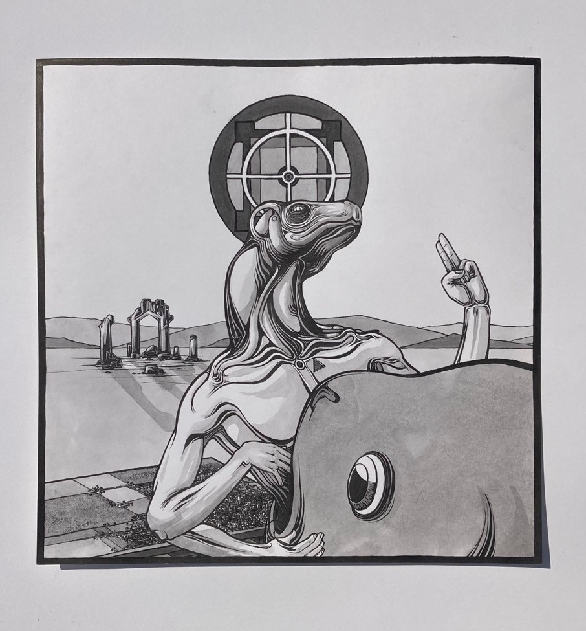

Those pious didacticians. What were they thinking when they raised their eyes to the sky and muttered their inanities?

As if bourgeois hippies and vacationing collegians, hitch-hiking across America to find their schizophrenic selves, still held out plaintive signs, shirtless and unshaven, on the highways of today. As if we or they foresee a future of 50’s-era monorails or cars from the Jetsons.

Those old ways are in ruins.

What did the natives aspire to once we stole their land from them?

What did the fish think facing extinction?

When Cortes came to America, the Aztecs fled from Tenochtitlan to the uncontacted tribes of Mesoamerica and were never heard from again. No one could have known the stakes that day, bartering for their lives with their animals heaped around them. Just another beating, so they thought: taken or delivered—what did it matter? They never imagined the vicious pieties of the victors, the vast landscapes of America ranched and mined to sterility.

They say you were lucky to be a 60s kid, not for the mythical sex, not for the drugs and the music, but simply to have crossed those plains in time to experience them.

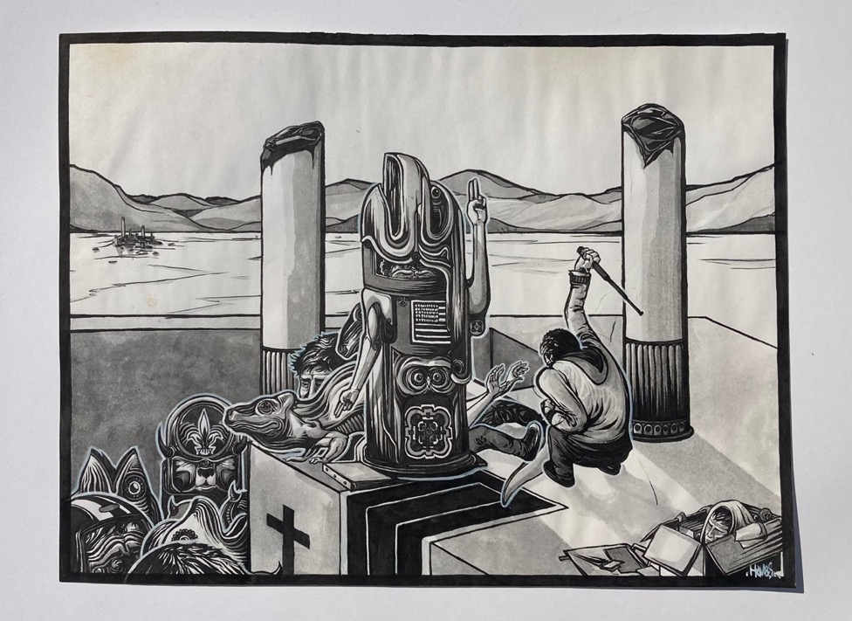

3. TO THE FISHING GROUNDS

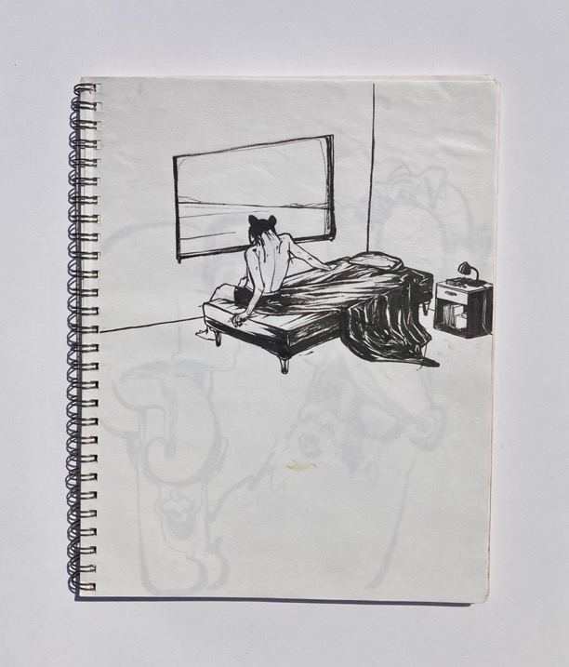

The sea was flat; the sky as mid-January. ”Never too early,” the captain said and of course would say again.
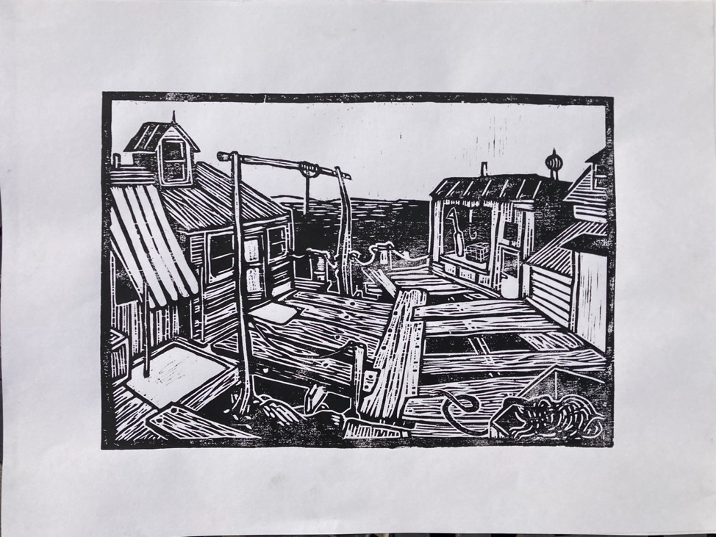

I walked down the bait-slicked ramp and all the boats were gone, gone chasing the Great White Whale or the great white, or maybe a day’s pay, or maybe just time away from home. The wharf planks sistered up under the warp coils, davits like gallows and the bait shack like a prison cell.

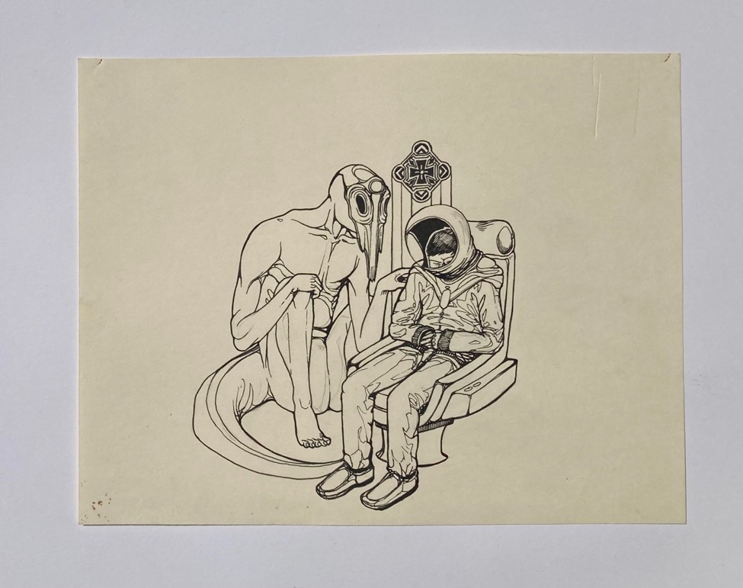

“There’s no going at all when it’s going for nothing these days,” the old fisherman warned, “pounds all closed and the sardine carriers lounging in Gloucester. Nothing but cruise ships, filming the mosquitoes and the mud. So look picturesque as for the camera lens.

“There’s really not much to this business,” he continued. “You keep the bait and fuel costs under gross and split the rest as you see fit. It ain’t rocket science. You don’t need Margaret freaking Hamilton (the hot one) embracing a self-sized pile of computer code for the moon landing; you don’t need to calculate like Leibniz.“

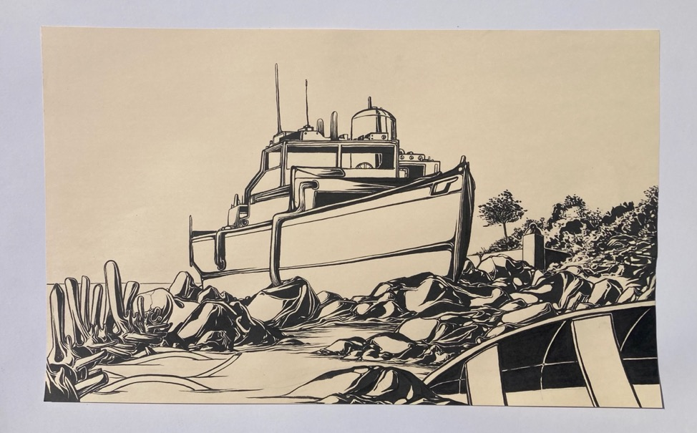

We cast off and within the hour circled back to the dock again. It was only a splash or a cup-ful of diesel, Toby said, as he brought the hammer down and the boat fairly planed to the pilings; you could afford the fuel, and what was time to you? the coffee, on the other hand: “It’s not like the laws of thermodynamics will be suspended for our convenience,” he said, worried he might have mis-quipped his excuse for returning.

The exhaust stacks came straight through the floorboards back then and on cold days, every chance I got I wrapped myself in the warm asbestos covering.

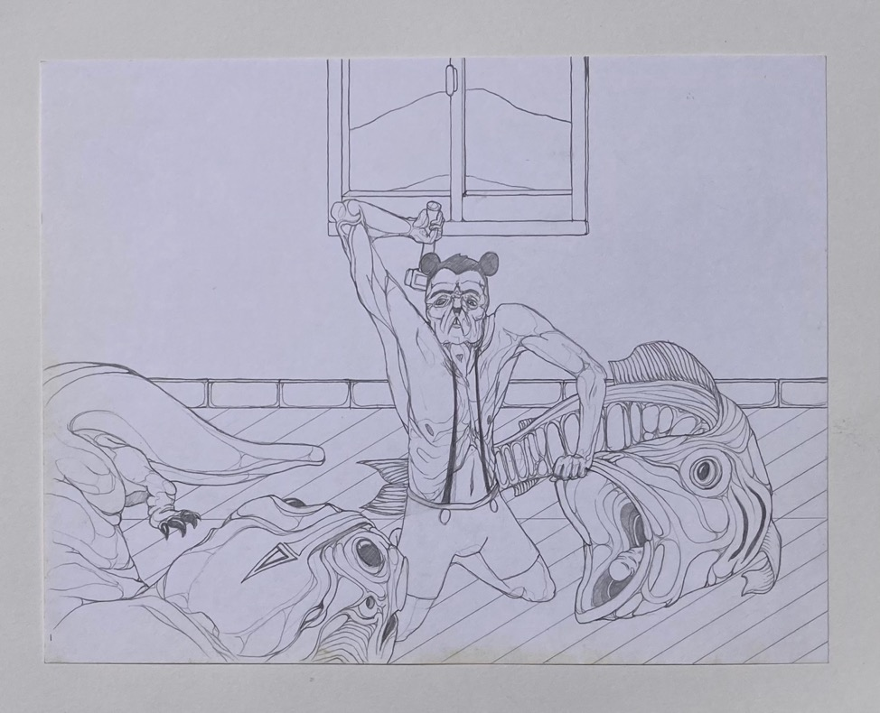

So we baited up with fish carcasses, no longer fish, I guess, ‘cuz you know what they say they say once you’re friggin’ dead that’s it even the body left behind ain’t yours or you in any sense. The fish you land ain’t fish and the fish you sell ain’t fish and the fish you eat ain’t fish, nope. Can’t even take what I call my fish home to my family, they say, it’s like eating money and I’d rather spend a day’s pay on a restaurant bill from Cooks and commemorative tee-shirts stitched in Sri Lanka.
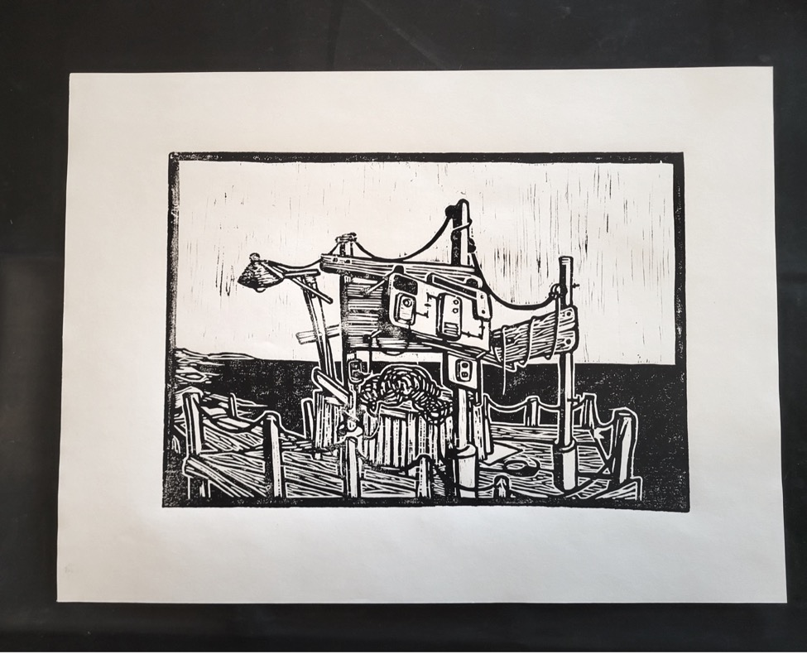
Nothing will have changed in the harbor when we bring the catch in, he assured me. We’ll see the same wharf, planked erratically, the lamp that guides us home, the warp coiled like some beast emerging from the woodwork—all inked on the rough grain of the woodcut block itself.

A rope rail like those in ticket lines, or outside toney restaurants.

A boat cut like a kid’s boat—Look closely, now!—out on the horizon.

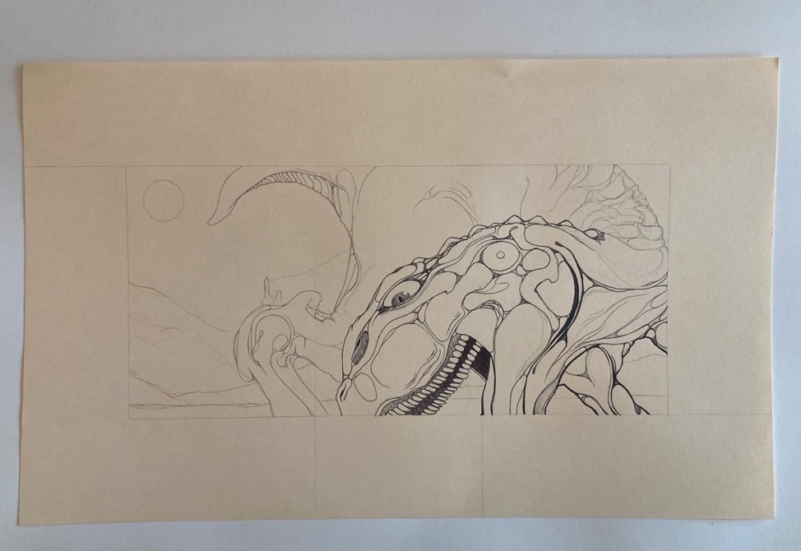

During winter, out past the Sisters in the sea smoke, we ran the water from the heat exchanger right out onto the floorboards, he said, mixed in with the by-catch for if your feet didn’t get bit with frost or end up with chilblains, we figured, how bad could it really seem to be?
4. MISGIVINGS OF MIDDLE AMERICA

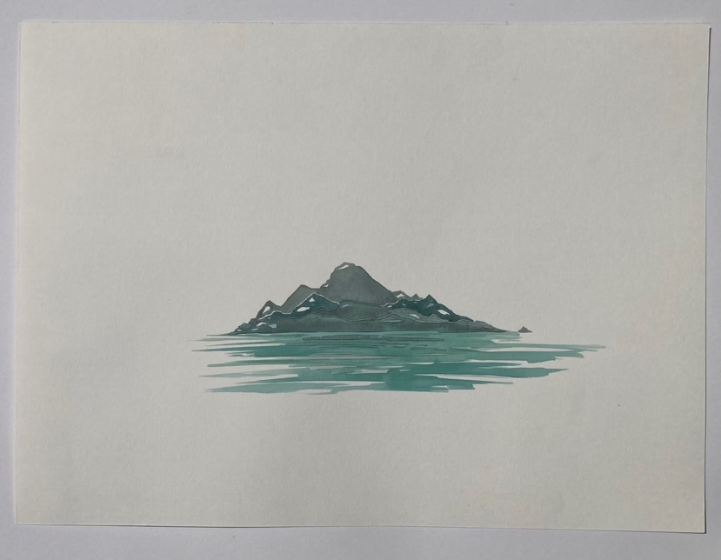
It was out on the Great Plains of America just east of the Dakotas where you sang of the settlers, their “oneness with the land,”—abstracting the unsettling essence of the thing!—like the fishermen one with the sea, as if freed of the realities of biology and history, the greed of the wholesalers, the economies of futures.

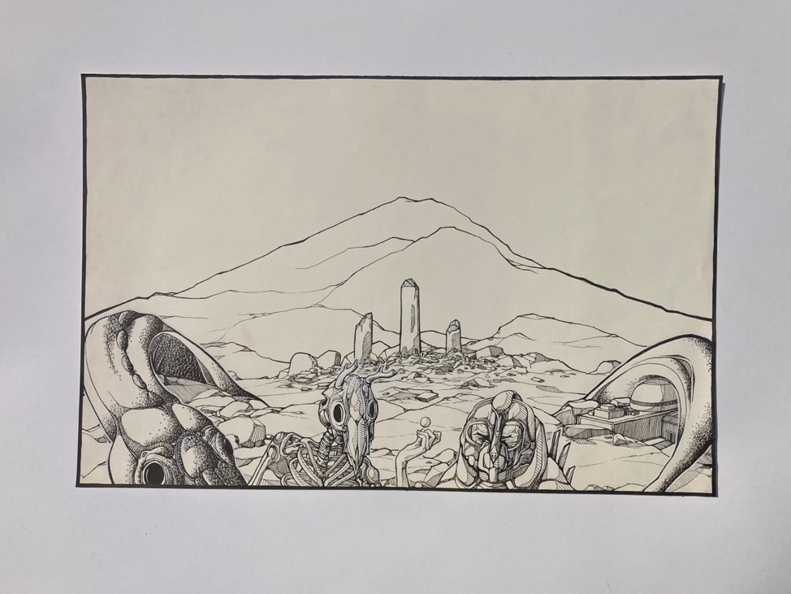
And when she held you, thinking of her childhood in the abusive dusts of Iowa, "They get old before their time, ground down to dirt itself,” she said, speaking of the farmers working the land passed down to them, not stolen, so they reason, from the natives. “They are shocked to find it happen, as if one day, straining against the bale, it had all gone bad for them at once.”

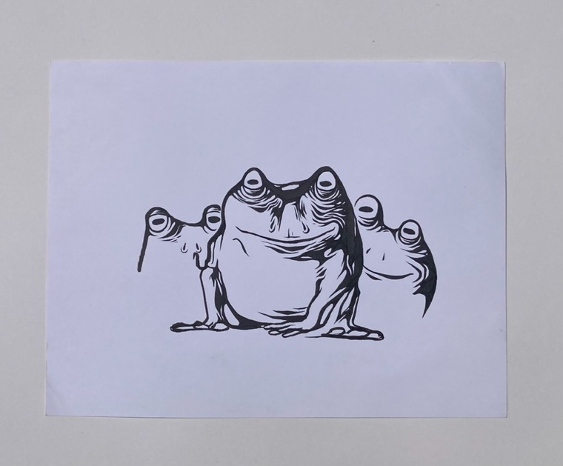

“We all,” I tried to say, then pompously, “at some point in our lives,” pausing for effect, “and for a young woman as yourself …” but she was hardly listening.

“And what should I expect,” she said, joking as she always did, “here in the stagnant wastes of the spring? here in the wheel ruts? Like some boss, teacher as yourself, perhaps, policeman, or frog Prince will assault me and I will live with and in my spawn forever?
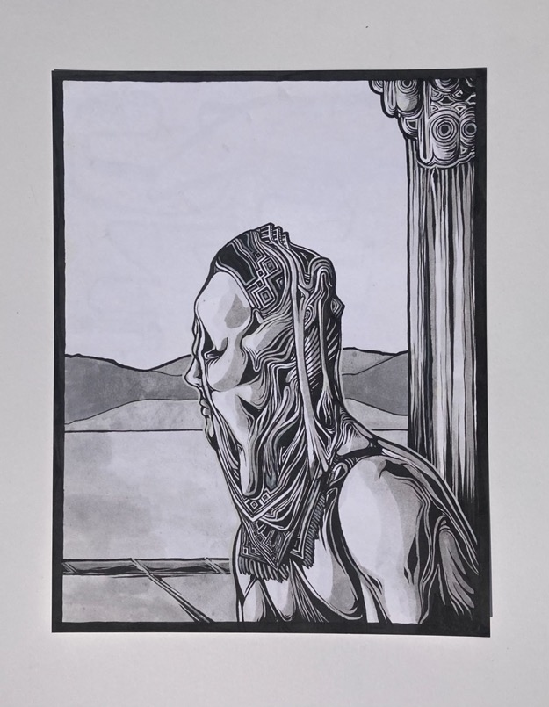

“What more should I expect? in this poisonous air and the soil packed hard over the aquifers?”
The Sooners take their positions.
What was the point of getting up in the first place?
The seeds dry and the very land contested.

No fish to be had like for the fisherfolk, they grumbled, just another morning working one of the stolen forties. Breathing the foul air. A box of machine parts for the machines that broke down beside you.

She forgave you, so the rumor is, (I doubt there’s much truth to it)—the girl who lay with you in the tall grass by the run-off lake that weekend in October. Years ago, it was. No full pardon, of course, but she acknowledged you had asked.
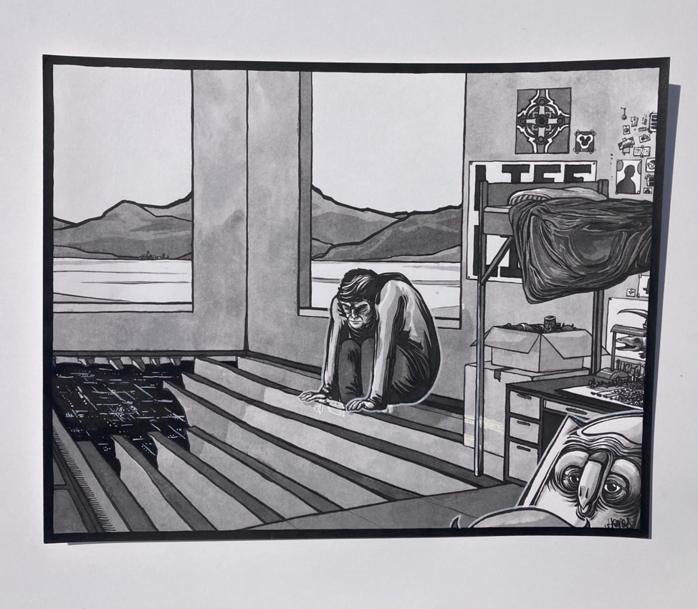
5. TUNDRAL STEPPES EAST OF KODIAK

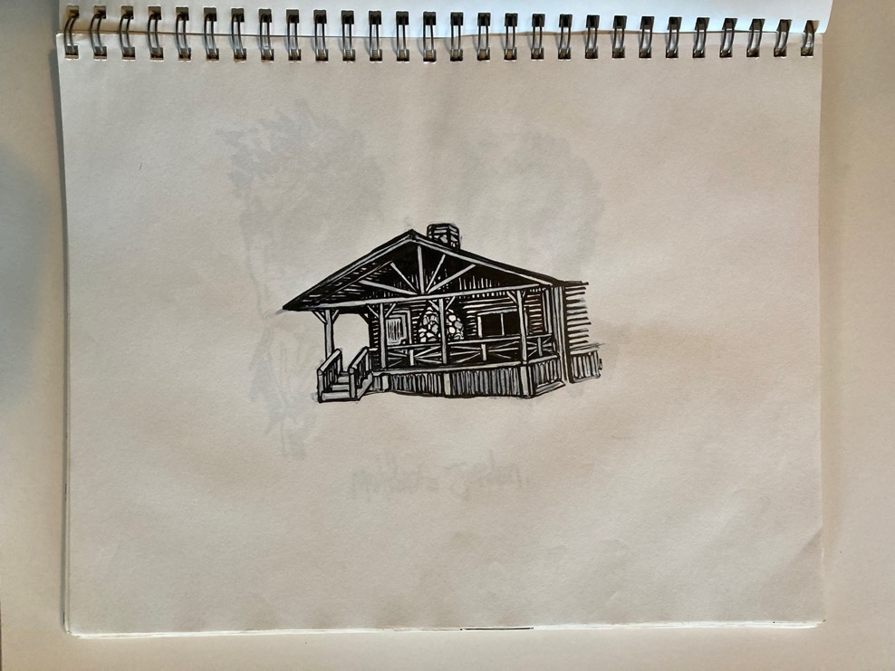

Ole Dick Proenneke spent thirty years in the cabin he built in Alaska with nothing but hand tools, up on the Northern Corridor but miles from Mombasa. And that went well for him, away from the towns and harbors demanding of his skills, well, until he died, and after that as well. Five volumes of notebooks, hand-written and articulate, the PBS film with his words revised and his voice voiced-over.

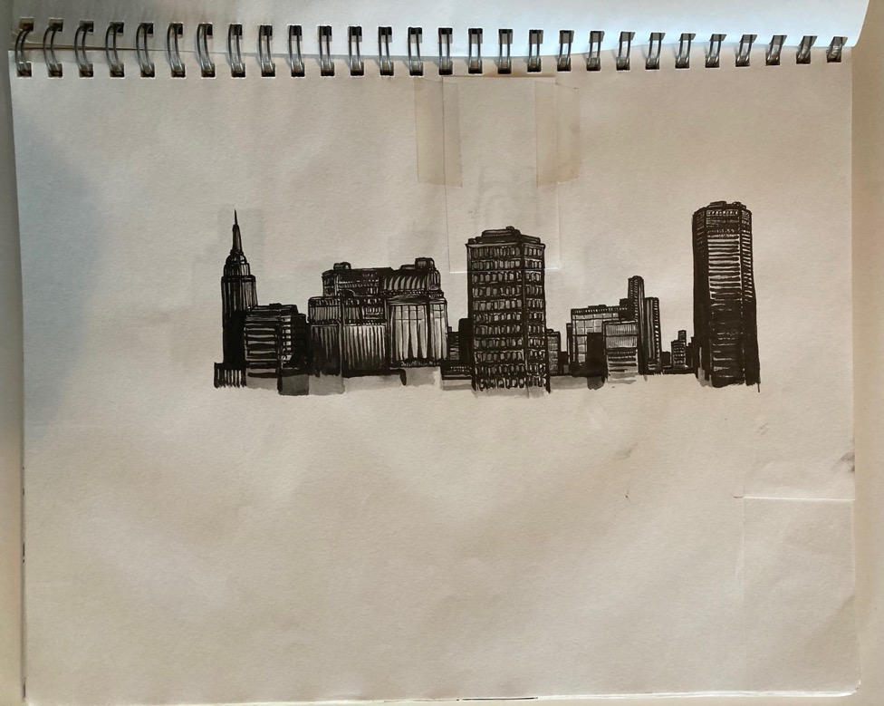

No soot-ridden cities for that guy, no buildings but his own and the huts of the big-game hunters, flown in for the slaughter. Dozens more each season so it seemed, until it was as bad as urbanity itself.

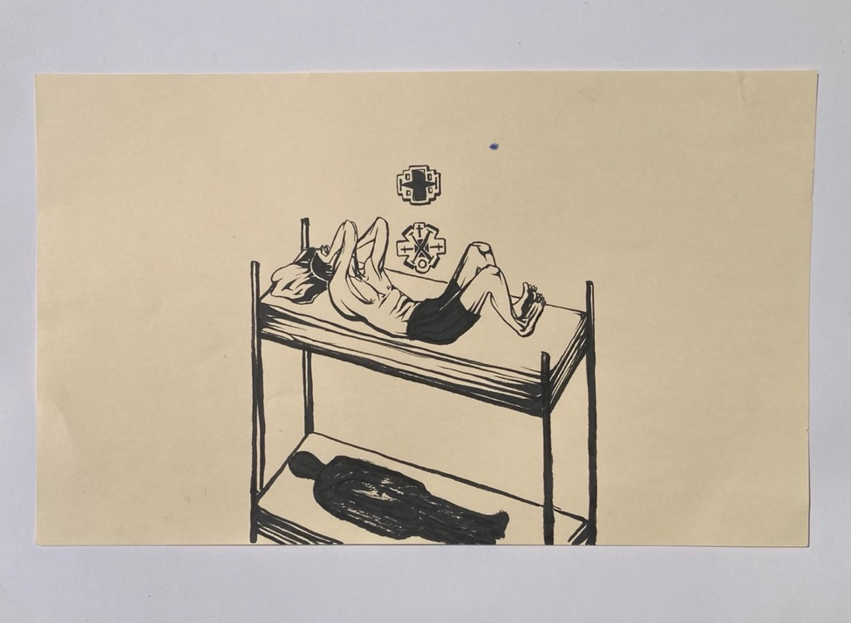

It must have been for him as it was for me the night I spent at the hunting camp in Brownville Junction, freezing my ass off in the chill despite the glare from the wood stove. Like those days in the prison cell I imagined, or maybe it was visiting a warehouse dorm one day top bunked and vomiting out a half-case of beer into the walkway.

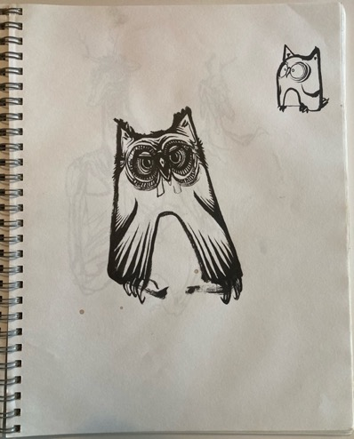

Five hours he spent bent in the spruce tree, dead of winter or nearly so, waiting to film the owlets in the owl’s nest, and that unnerved me, I tell you, thinking of Percival’s conversation self-reported with a native man, So what duz it taste like, your rattlesnake or maybe he was talking about marmots, free for the taking on public or taken land “Waaaal,” the old native said to him, “it’s a lot like owl,” he said.

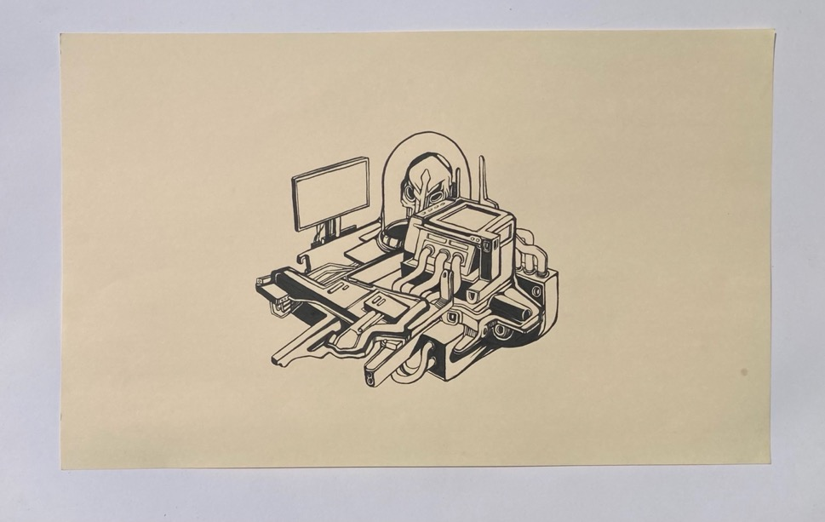

Too bad we can’t all forge up new forks for the motorcycle as Pirsig did, or rebuild a diesel when the bearings seize as Ole Dick would.

Christ I don’t know intakes from exhaust manifolds, but it was that very word in the Kant translation that turned things around for me, and for once, damn!, I got it! like the manifold of sensory impressions, you see? that’s what reality is, not the inaccessible things themselves, and I came away all swelled in the pride of Verständnis and by noon I couldn’t remember a damn thing.
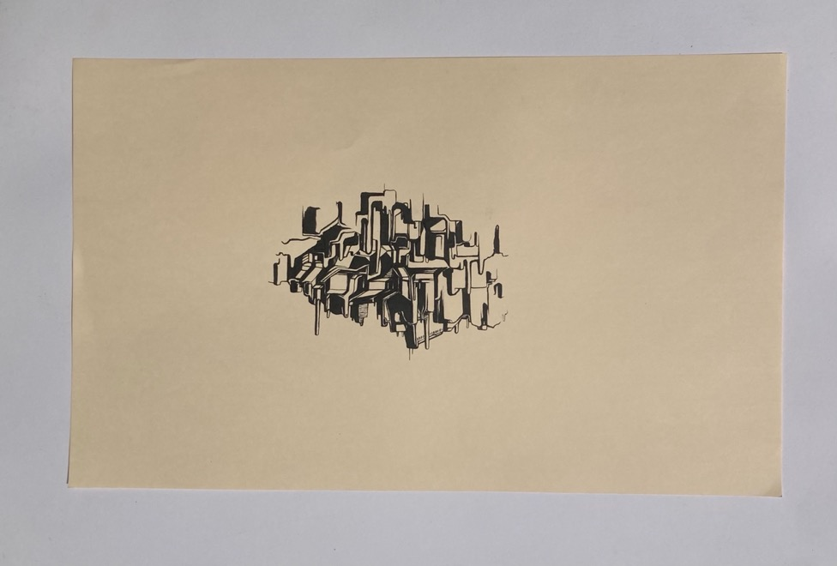
The planes flew supplies to Twin Lakes, climbing through the frozen mist over the mountains, weighted with beer and game hunters. In spring, when the ice broke up and made landing treacherous, they would drop Dick’s mail onto the beach, promising to return with a conventional dip of the wings.

You had to wear glasses to prevent snow blindness during the first snows of August.

6. SANDSCAPES

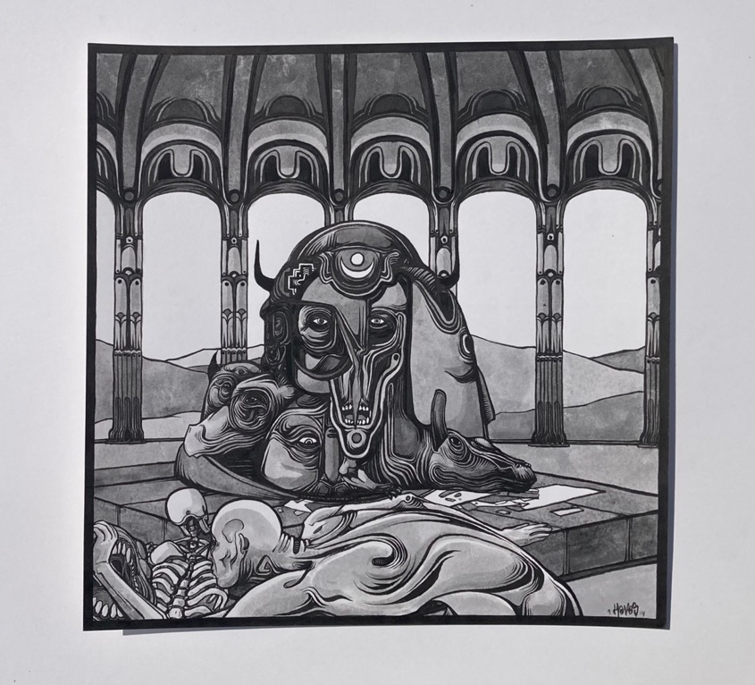

The road swung south to the great southwest where Dvorak invented America as some insist and Georgia O’Keefe made the detritus of the land grab seem like it had been ours forever,

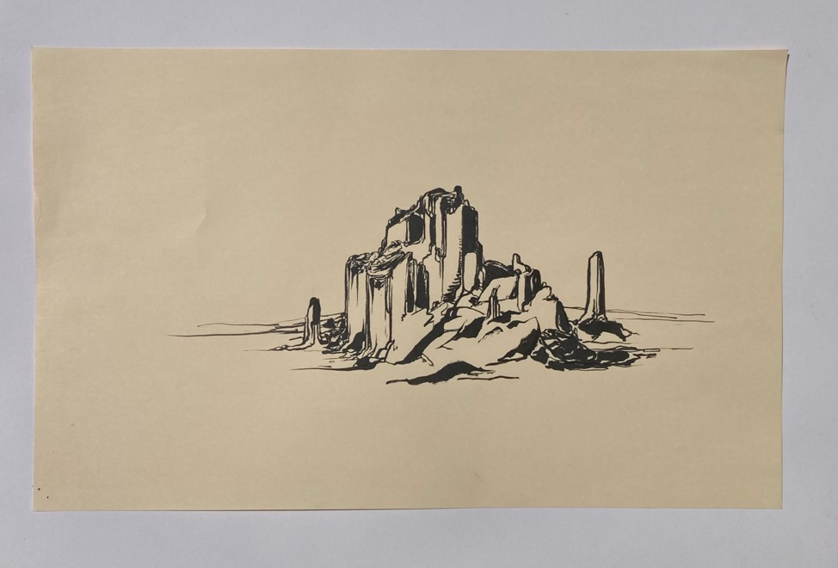

Slabs of sandstone buttes caught in the sun or the frames of the John Ford movie. Like vast cities or the remnants of one, after the bombs fell.

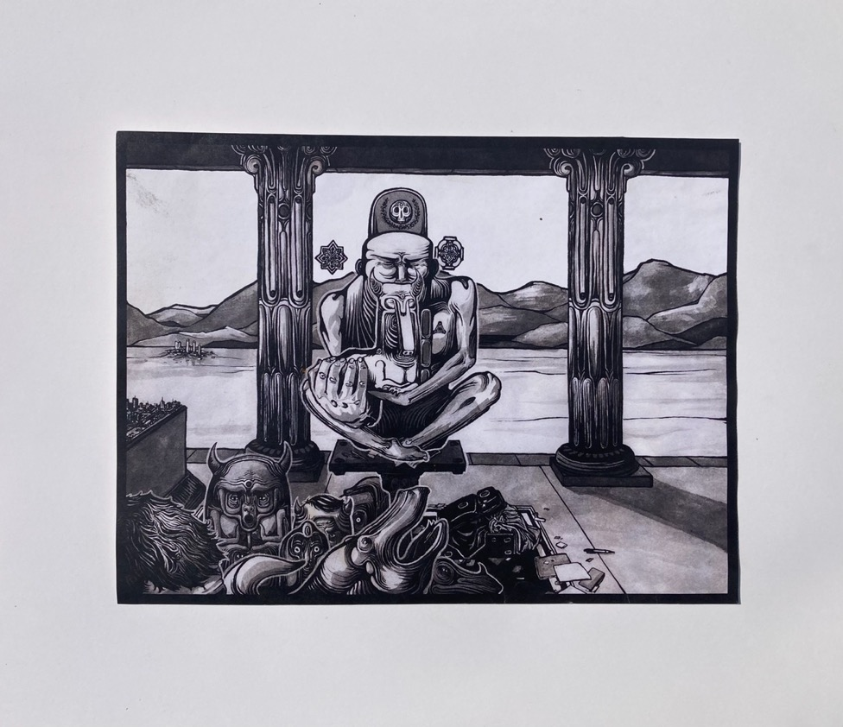

A landscape worth the contemplation, you thought. A rich store of motifs and melodies; the palette of pastels. All there for the taking.
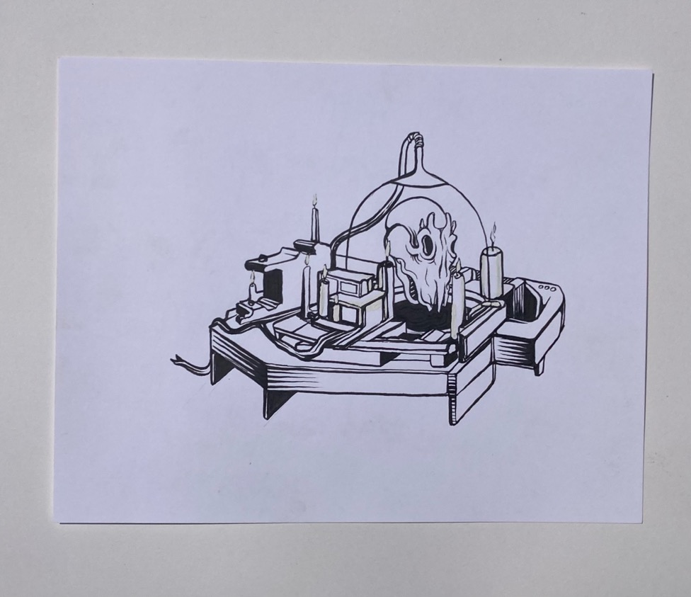
But you are wary of the vast sublimity of things. You’ve seen the photos: the heaps of buffalo skulls to be ground up as fertilizer. The tailings of copper mines. You wince at the adobe shaped into repeated shapes in the adobe bungalows of Santa Fe; for she you mourn for died in one of them.

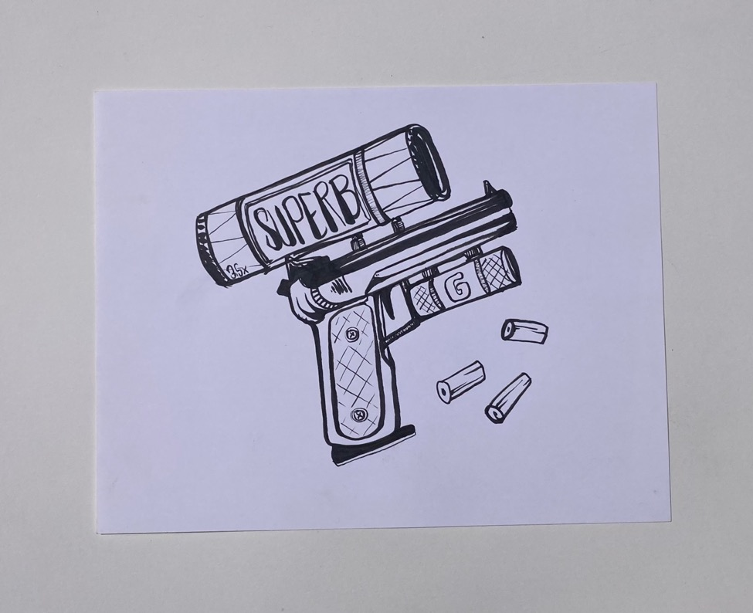
That was where she grew and where one early April day, the soil still gripped in frost, she drove home for the last time with the handgun boxed on the seat beside her.

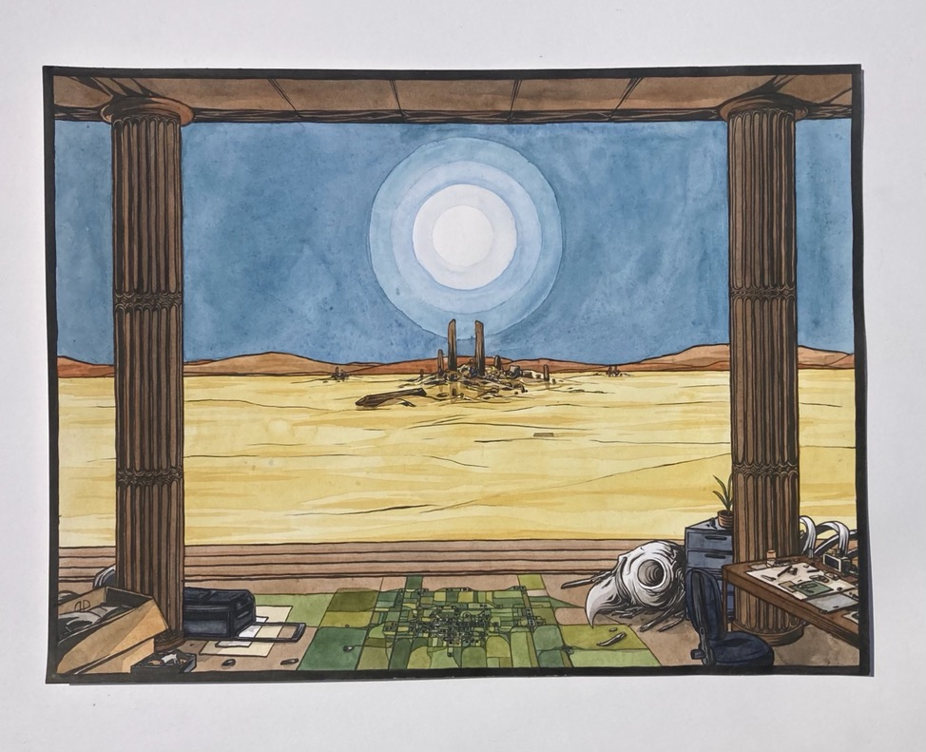

It was a small grave she imagined, as the dogs chased debris caught in the wind. One meant for a child, she said, the child that she herself had longed to be, tying her ballet shoes, writing puppet plays with her sisters, her future then as open as the land itself. Pine, she said, or whatever was cheapest here. It would do, she insists, and we sat in what I may as well call the fading sun, as the afternoon breeze died and she died too, her body weight still pressed against me. I embraced her, stealing the last warmth of her, and my thoughts ran stupidly to biology labs, ATP and the Krebs cycle, the scents of preservatives.

“When I am big,” she wrote once in the children’s book.

“When I am big …”

7. LAUDATIO TEMPORIS ACTI

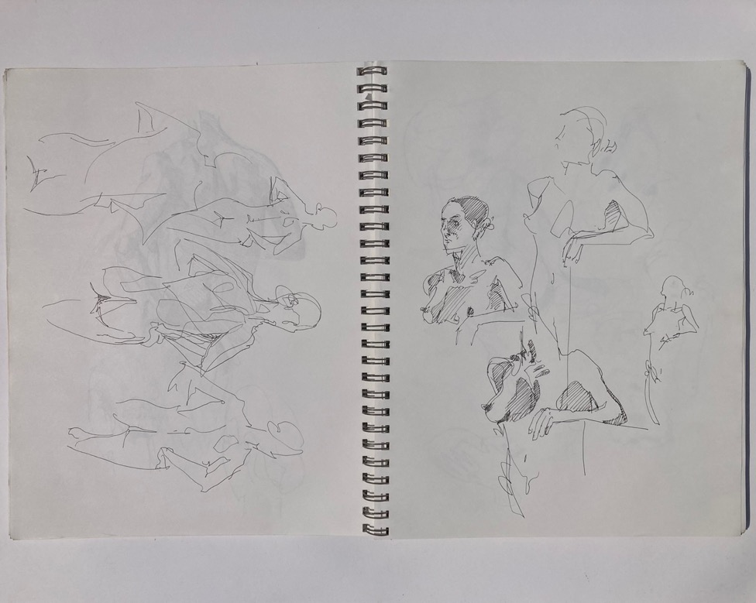

Maybe it was easier in the old days. You got up and drank your imperial coffee or your tea and never thought twice about it. You broke out the sketchbook and wondered if you would ever fill the pages you left in the binder. No one died in those days. No one aged, as they do today. The scene was set, as Stevens says. “It repeated what was in the script.”

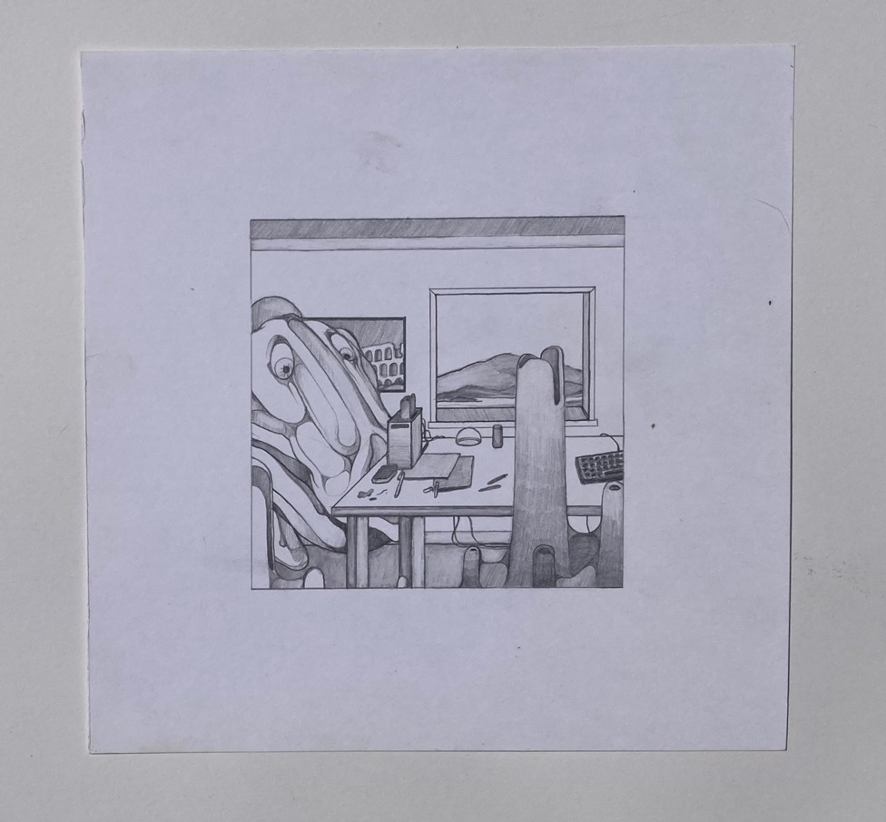

You put in your time and waited for the sun to set or for the guts of a Rolex to tell you you were free.

You sketched things out for the future—the lines now fine and precise. Everything proscribed in the French curves and the straight-edge. Like the proofs you learned in geometry and the unassailable truths of pubescence. The trisected angle; the formula for pi. The vectors of experience.
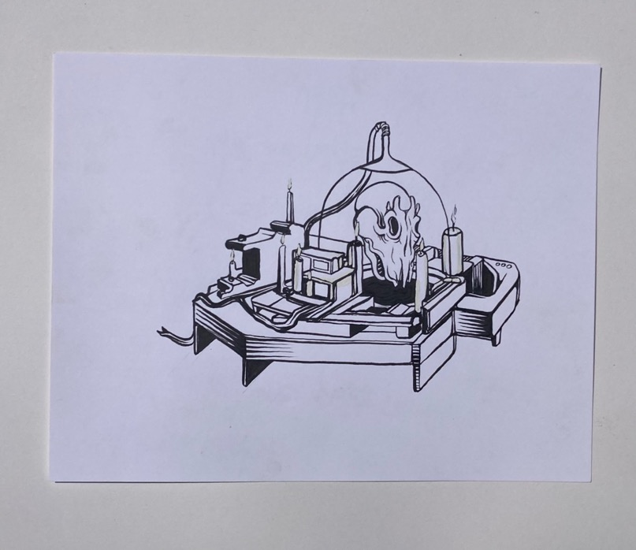

Some wrote by hand In those days, others with the IBM Selectric; maybe a novel on an old Kay-Pro or Apple II (the latest thing). Others, I’m sure, simply read aloud, slowly and precisely, into an old Dictaphone.

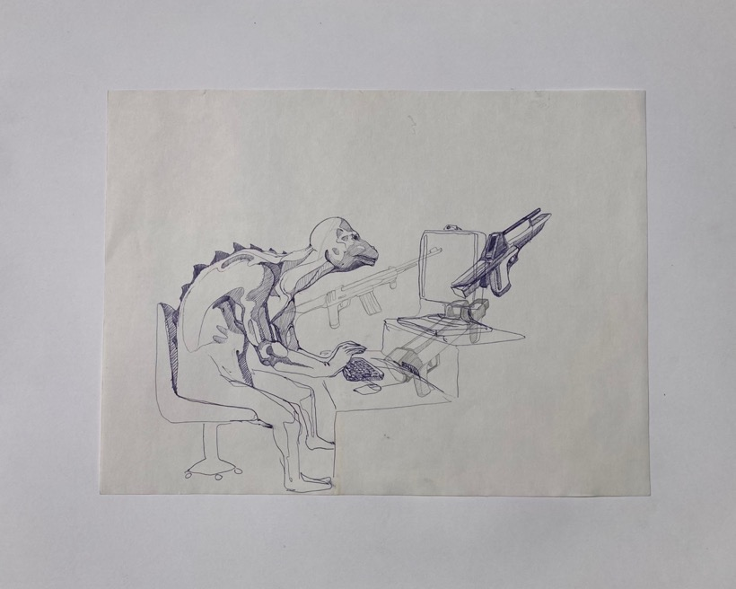

Eight years of apprenticeship it took to reach the rank of journeyman: just a journeyman; only a journeyman. Like the print of the woodcut, that is, the image, not the cut itself. Not the real artist, his workspace cluttered with sketchpads, but his likeness, dreaming of commissions and the unexampled windfall of a listener.
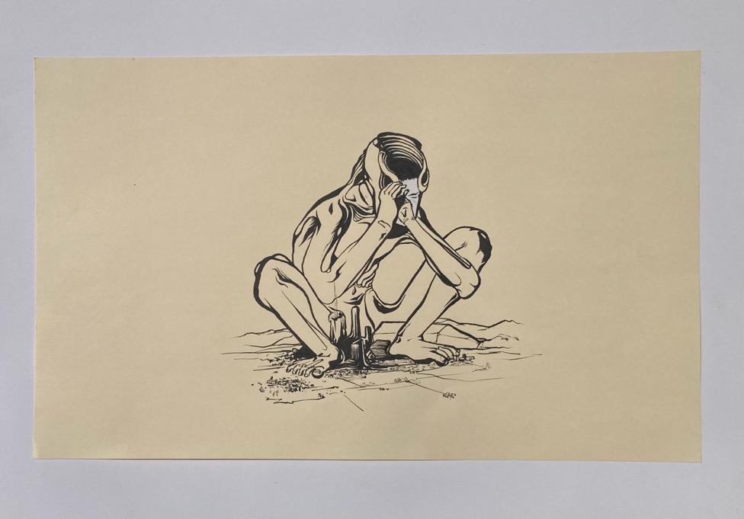

And one day the reviews came in.

You think invidiously of the prize-winning novels of your colleagues, most in their second printing; you think of paintings hanging in museums; violin recitals; lecture tours in the Rockies.

Just words, you try to think, the snide remarks of some old geezer newly-shaven in a creased suit.

The waste fell through the floorboards.

And then it came to you.

Do not get lost in the obliquities of surfaces.

(The words of the sage again!)

The cross-swells against the wind.
The illusions of the self:

ships are past whose wakes are felt.
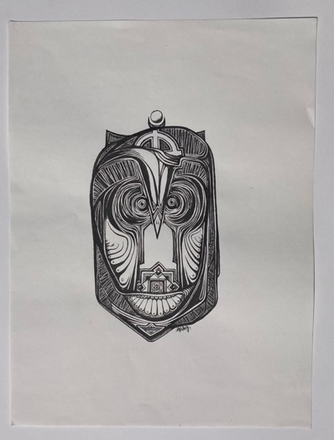

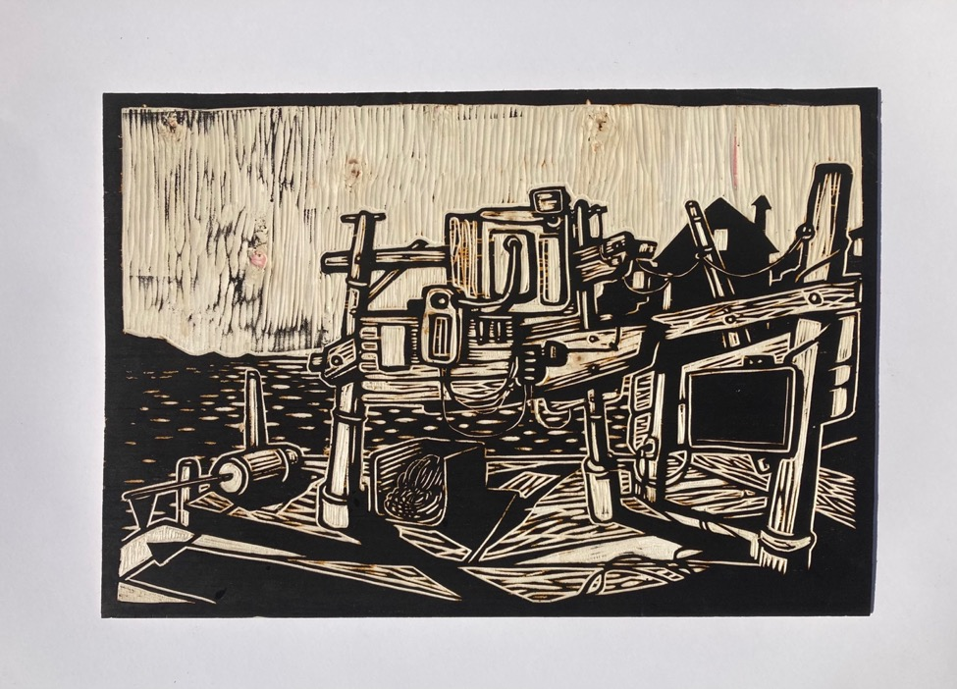

A wharf, then, like one you’d dream about,
the ole’ res ipsa, thing itself:
the light impossible,
no one to view or decipher it,
the buoy without function,
the cordage coiled without purpose
wood-cut planks opposed to the cross-beams.

Fin

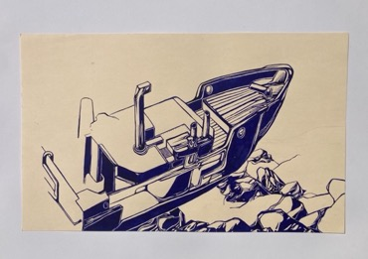

Zach Havas is an artist from Harpswell, Maine via Paris, France. Inquiries and portfolios: Zhavas@gmail.com

Joseph Dane is from Harpswell, despite having spent forty years teaching in Los Angeles. His work is available on FreeReadPress or in hard copy from amazon.

